Subcutaneous (sub cut) and Intramuscular (IM) Injections
This document is uncontrolled when downloaded or printed.

Copyright © Care4Quality Ltd All rights reserved.

Reference number | REGCP28
Version | 1
Author | D Martin
Owned by
Date ratified
Ratified by:
(Signed)
Issue date
Review date:
(Signed)
Target audience | Registered Managers, Registered Nurses, Care Team

1 | Purpose & Application
2 | Responsibilities
3 | Legislation & Regulation
4 | Subcutaneous and Intramuscular Injections: Policy & Procedure
5 | Equality Impact Assessment
Contents
- Purpose & Application
This policy has been developed to provide guidance and information about how to set up and use a syringe Driver.
What is an Intramuscular (IM) Injection?
Sites for an IM Injection
How to Administer an IM Injection
Complications of IM Injections
What is a Subcutaneous (sub cut) Injection?
Subcutaneous Injection Sites
How to Administer Subcutaneous Injections
The policy will apply to:
- Permanent employees
- Temporary employees
- Agency workers
It will be the responsibility of managers to take any necessary action if this policy is not adhered to, taking into account the relevant regulatory responsibility.
- Responsibilities

The nominated individual is accountable for the implementation of this policy in its entirety. They are a key contact for the service.
The registered manager and any trained nurses are responsible for the implementation of this policy.
Any care staff that have had training and been deemed competent in the administration of subcutaneous and intramuscular injections.

- Legislation and Regulation

Health and Social Care Act 2008 (Regulated Activities) Regulations 2014: Regulation 12

The intention of this regulation is to prevent people from receiving unsafe care and treatment and prevent avoidable harm or risk of harm. Providers must assess the risks to people's health and safety during any care or treatment and make sure that staff have the qualifications, competence, skills, and experience to keep people safe.

Providers must make sure that the premises and any equipment used is safe and where applicable, available in sufficient quantities.
Providers must prevent and control the spread of infection. Where the responsibility for care and treatment is shared, care planning must be timely to maintain people's health, safety, and welfare.

CQC understands that there may be inherent risks in carrying out care and treatment, and they will not consider it to be unsafe if providers can demonstrate that they have taken all reasonable steps to ensure the health and safety of people using their services and to manage risks that may arise during care and treatment.

CQC can prosecute for a breach of this regulation or a breach of part of the regulation if a failure to meet the regulation results in avoidable harm to a person using the service or if a person using the service is exposed to significant risk of harm. They do not have to serve a Warning Notice before prosecution.

- Subcutaneous and Intramuscular Injections: Policy & Procedure

Intramuscular Injections
An intramuscular injection (IM) is an injection of medication into the muscle through the dermis, epidermis and subcutaneous layers and is used for medications that are soluble, used in small amounts and do not irritate soft tissues.

Intramuscular injections are absorbed faster than subcutaneous injections. This is because muscle tissue has a greater blood supply than the tissue just under the skin. Muscle tissue can also hold a larger volume of medication than subcutaneous tissue.

Medications that can be administered via this route include:

- Vaccines,
- Antibiotics,
- Antiemetics,
- Analgesics and Sedatives.

As muscles are well perfused, there is a rapid systemic action, although it is slower than medication injected intravenously. The volume of medication that can be administered depends upon the size of the muscle bed - 5mls into large muscles, 1-2mls into smaller muscles.

The four main injection sites for intramuscular injections are:

1. Upper arm (deltoid). This site is the most accessible site. However, it is only suitable for relatively small amounts of solution. Typical volume of medication is 1 - 2ml. The muscle is in the upper arm approximately 2.5 to 5 cm below the lower edge of the acromion process. The needle is inserted 2.5 cm below the acromion process on the lateral aspect of the arm. The muscle will relax if the person is asked to put their hand on their hip.

2. Upper outer quadrant of buttock (dorsogluteal site). This is the most popular site for deep intramuscular injections. As it is a fairly large muscle, it can withstand large and repeated injections. However, the gluteus muscle does have the lowest drug absorption rate. It is vital that this area is correctly identified, as the sciatic nerve and the superior gluteal artery lie in the medial part of the buttock. These structures can be damaged, especially in elderly, emaciated or a non-ambulant patient, as the muscle mass is likely to have atrophied. In mildly obese patients,
injection into this area is likely to be into the adipose tissue rather than the muscle, therefore resulting in slow absorption of the medication.
Typical volume of medication is 2 – 4 ml. It is found by making an imaginary line drawn horizontally across from the top of the cleft of the buttocks to the greater trochanter of the femur. Another line is then drawn vertically midway along the first line. The upper outer quarter or quadrant is used.

3. Lateral aspect of the thigh (vastus lateralis). This is also a large muscle and is used for deep intramuscular injections. It is easy to access, especially if the patient is unable to turn onto their side. There are no major blood vessels or significant nerve structures associated with this site. Care should be taken in obese patients that the drug is delivered into the muscle and not the subcutaneous fat. Typical volume of medication 1 - 5ml. In an adult, it is found by measuring a hand’s breadth down from the greater trochanter of the femur and a hand’s breadth up from the knee on the lateral side of the thigh; this identifies the middle third of the muscle.

4. The ventrogluteal site (gluteus medius). This is an alternative site to the dorsogluteal site. It avoids all major nerves and blood vessels and can be used for administration of narcotics, antiemetics, sedatives and deep intramuscular injections. Typical volume of medication 1 - 4ml.
Location: palm of hand placed onto patient’s greater trochanter. The index finger is extended to touch the anterior superior iliac crest and the middle finger is stretched as far as possible along the iliac crest to form a V. The needle should be inserted into the middle of the V.

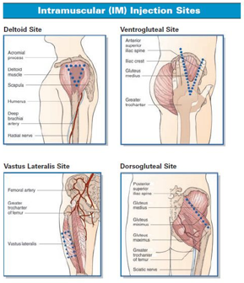
The needle must be long enough to penetrate the muscle and still allow a
third to a quarter of the needle to remain external to the skin. Most commonly used sizes are – 21g (green) or 23g (blue) and are 2.5 – 5 cm long.
The muscle mass, amount of subcutaneous fat and the weight of the patient should be assessed before deciding what size needle to use.
How to Administer an Intramuscular (IM) Injection

- To commence the procedure, it is important to make sure hands are washed and the patient is identified to ensure that the injection is given to the right person.
- Explain the procedure to the person and gain their consent. Receiving an IM injection can be a painful procedure and the person should be warned about the possibility of pain.
- Check the name, dose, route, and expiry date of the drug to be administered against the prescribed instruction on the MAR chart.
- Check for any known drug allergies or adverse drug reactions in the past and make sure that the person does not have an allergy to the prescribed medication.
- Assess the proposed injection site for signs of inflammation, oedema, infection, and skin lesions.
- Clean the skin and allow to the skin to dry completely.
- Stretch the skin around the injection site with thumb and forefinger. Hold the needle and syringe at 90° to the skin surface and quickly but gently plunge into the skin. Leave a third of the needle length visible. This is done in case the needle breaks so it can still be removed.
- Pull back the plunger. If blood is seen, remove the needle and syringe and apply pressure to the site until haemostasis has been achieved. Start again with a fresh set of equipment.
- If no blood is seen, then inject the drug slowly (approximately 1ml/5-10 seconds).
- Remove needle and apply pressure. Applying pressure may help preventing a haematoma formation.
- Dispose of the needle and syringe into a sharps bin and record the administration of the drug on the MAR sheet and check the person’s welfare.

Aftercare
Monitor and look for any localised signs such as redness, bleeding, swelling or pain, and observe the person for a minimum of 15 minutes following an injection for any signs of a drug reaction.

Complications of Intramuscular Injections
Some complications that may occur following an intramuscular injection can be local infection and abscess formation, when injecting in the gluteal region sciatic nerve injury can occur if the right area is not used, repeated injections at the same site may result in local fibrosis, but most complications following an IM injection are related to the drug injected.
There may be pain or discomfort following an injection, but this should resolve uneventfully.

Subcutaneous Injections
A subcutaneous injection (sub cut) is the administration of medication into the fatty vascular layer below the dermis. This route of administration allows a slow, sustained absorption of the drug. As there is less blood flow to fatty tissue, medications must be highly soluble to prevent irritation of the soft tissues. Medications that can be administered via this route include low molecular weight heparin and insulin as an example.

Sites for Subcutaneous Injections
Abdomen (in the umbilical region), lateral or posterior aspect of the lower part of the upper arm, thighs (under the greater trochanter rather than mid-thigh), buttocks.
How to Administer a Subcutaneous (sub cut) Injection
Different people have different amounts of subcutaneous tissue. When selecting needle length, it is important to observe the amount of subcutaneous tissue present, e.g., people who are anorexic or wasted due to underlying disease will have a fairly thin layer of fat. People who are athletic and very fit may also have limited amounts of subcutaneous fat available for sub cut injections. Diabetic patients are advised to rotate their injection sites as this can decrease the likelihood of irritation and ensure that the insulin is absorbed adequately.

- To commence the procedure, it is important to make sure hands are washed and the person is identified to ensure that the injection is given to the right person.
- Explain the procedure to the person and gain their consent.
- Check the name, dose, route, and expiry date of the drug to be administered against the prescribed instruction on the MAR chart.
- Check for any known drug allergies or adverse drug reactions in the past and make sure that the person does not have an allergy to the prescribed medication.
- Expose the chosen site and assess the site for signs of inflammation, oedema, infection, and skin lesions.
- Clean the skin and allow to the skin to dry completely.
- Some drugs are available in pre-filled syringes and manufacturer’s instructions should be followed and it is important to disperse any air bubbles from the syringe.
- Gently pinch the skin up into a fold. This action will elevate the subcutaneous tissue and lift it away from the underlying muscle layer.
- Insert the needle into the skin at an angle of 45° (unless the giving insulin which should be at 90°) and release the grasped skin and inject the drug slowly. Shorter needles allow the injections to be given at a 90° angle.
- Remove needle and apply pressure. Applying pressure may help preventing haematoma formation.
- Dispose of the needle and syringe into a sharps bin and record the administration of the drug on the prescription sheet and check.
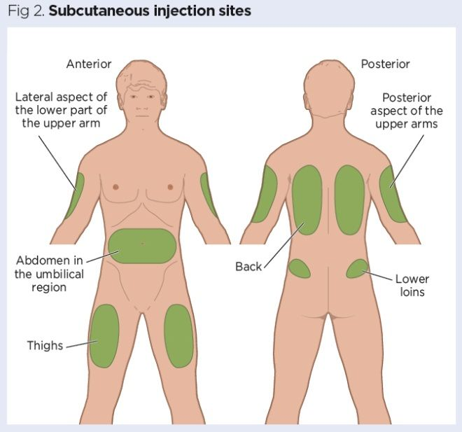

It is the responsibility of the person administering the drug to check the person for any adverse reactions.

It is important that, when administering an intramuscular or subcutaneous injection, a sharps bin is always at hand to dispose of the needle and syringe safely when used and is within infection control guidelines.

All diagrams used are for example use only.

Service Specific Information

5. Equality Impact Assessment

Equality Impact Assessment Checklist |  | Yes/No? | Comments
1. | Does the procedural document affect one group less or more favorably than another on the basis of:
 | - Race? | No
 | - Ethnic origins (including gypsies and travelers)? | No
 | - Nationality? | No
 | - Gender? | No
 | - Culture? | No
 | - Religion or belief? | No
 | - Sexual orientation, including lesbian, gay and bisexual people? | No
 | - Age? | No
2. | Is there any evidence that some groups are affected differently? | No
3. | If you have identified potential discrimination, are there any exceptions valid, legal and/or justifiable? | N/A
4. | Is the impact of the procedural document likely to be negative? | No
5. | If so, can the impact be avoided? | N/A
6. | What alternatives are there to achieving the procedural document without the impact? | N/A
7. | Can we reduce the impact by taking different action? | N/A

If you have identified a potential discriminatory impact of this procedural document or need advice, please document the action required to avoid/reduce this impact.

