Venepuncture
This document is uncontrolled when downloaded or printed.

Copyright © Care4Quality Ltd All rights reserved.

Reference number | REGCP27
Version | 1
Author | D Martin
Owned by
Date ratified
Ratified by:
(Signed)
Issue date
Review date:
(Signed)
Target audience | Registered Managers, Registered Nurses, Care Team

1 | Purpose & Application
2 | Responsibilities
3 | Legislation & Regulation
4 | Venepuncture: Policy & Procedure
5 | Equality Impact Assessment
Contents
- Purpose & Application
This policy has been developed to provide guidance and information about Venepuncture
What is Venepuncture?
Service User Safety
Procedure
Post Procedure
Complications Associated with Venepuncture
The policy will apply to:
- Permanent employees
- Temporary employees
- Agency workers
It will be the responsibility of managers to take any necessary action if this policy is not adhered to, taking into account the relevant regulatory responsibility.
- Responsibilities

The nominated individual is accountable for the implementation of this policy in its entirety. They are a key contact for the service.
The registered manager and any trained nurses are responsible for the implementation of this policy.
Any care staff that have had training and been deemed competent in venepuncture procedures.

- Legislation and Regulation

Health and Social Care Act 2008 (Regulated Activities) Regulations 2014: Regulation 12

The intention of this regulation is to prevent people from receiving unsafe care and treatment and prevent avoidable harm or risk of harm. Providers must assess the risks to people's health and safety during any care or treatment and make sure that staff have the qualifications, competence, skills, and experience to keep people safe.

Providers must make sure that the premises and any equipment used is safe and where applicable, available in sufficient quantities.
Providers must prevent and control the spread of infection. Where the responsibility for care and treatment is shared, care planning must be timely to maintain people's health, safety, and welfare.

CQC understands that there may be inherent risks in carrying out care and treatment, and they will not consider it to be unsafe if providers can demonstrate that they have taken all reasonable steps to ensure the health and safety of people using their services and to manage risks that may arise during care and treatment.

CQC can prosecute for a breach of this regulation or a breach of part of the regulation if a failure to meet the regulation results in avoidable harm to a person using the service or if a person using the service is exposed to significant risk of harm. They do not have to serve a Warning Notice before prosecution.

- Venepuncture: Policy & Procedure

What is Venepuncture?
Venepuncture is a procedure that involves entering a vein with a needle and is usually carried out to obtain a venous blood sample for haematological, biochemical, or microbiological analysis; where the need for clinical investigations has been specified within a service user’s care or as indicated in the service user’s care plan.

Venepuncture is an essential skill undertaken by healthcare practitioners. Venepuncture should be performed in the anti-cubital fossa and should only be performed in the back of the hand (metacarpal veins) if it is not possible to obtain a sample from the anti-cubital fossa. Venepuncture must only be performed by suitably trained staff who have completed venepuncture training and have been deemed competent and have been signed off with evidence of venepuncture competency assessments.

Staff must understand both the legal and professional implication of venepuncture and adhere to the principles of infection prevention and control and health and safety regulations. Culture is a system of values, beliefs, and practices. Staff should be alert to, and ensure that they respect, any cultural and/or gender sensitivity issues.

Anti-cubital Fossa | The anti-cubital fossa is an area of transition between the anatomical arm and the forearm. It is located as a depression on the anterior surface of the elbow joint. It is the area most commonly used for venepuncture due to its sizable veins.
Metacarpal Veins | The metacarpal veins are located on the back of the hand and are easily visible and palpated. The use of these veins may not always be suitable in the elderly because of skin elasticity and subcutaneous tissues are diminished which makes the veins difficult to anchor.
Venepuncture | Venepuncture is a procedure that involves entering a vein with a needle and is usually carried out to obtain a venous blood sample.

Service User Safety
It is the responsibility of all staff undertaking venepuncture to check the service user’s medical history prior to the procedure to avoid any unnecessary complications. Use of a limb may be contraindicated because of an existing injury, disease, or treatment, e.g., fracture. If a site is contraindicated, staff must seek an alternative site for venepuncture.

If the service user has a history of fainting during venepuncture, they should lie down so that they are resting safely to reduce the possibility of a fall, which could cause injury.

Care should be taken with service users who have a history of bleeding disorders or who have been taking warfarin or other anticoagulants, as this may increase the time it takes the bleeding to stop. There may be a requirement for some service users, whereby advanced plans and preparations must be in place prior to the procedure, such as MCA/BI/consent/religious beliefs as an example, to be taken by the practitioner for the service user. If in doubt, do not perform the procedure and seek advice from senior colleagues. All venepunctures must only be performed on an individual basis.

Ensure the service user has the mental capacity to consent; as venepuncture is an invasive procedure, it will need to be documented that the service user has given informed valid consent for the procedure, whether that be written, verbal or implied, and that they have complied with any specific pre-test instructions. Everyone working with and or caring for an adult who may lack capacity to make specific decisions must comply with the Mental Capacity Act 2005 when making decisions or acting for that person. When the person lacks the capacity to make a particular decision for her/himself, any act done for, or any decision made on behalf of that person must be done or made in the person’s best interests (MCA 2005).

If English is not the first language or there is any disability such as visual, hearing impairment or learning disability, the practitioner must ensure relevant action has been taken to communicate effectively with the service user, for example the use of an interpreter or clear visual aids.

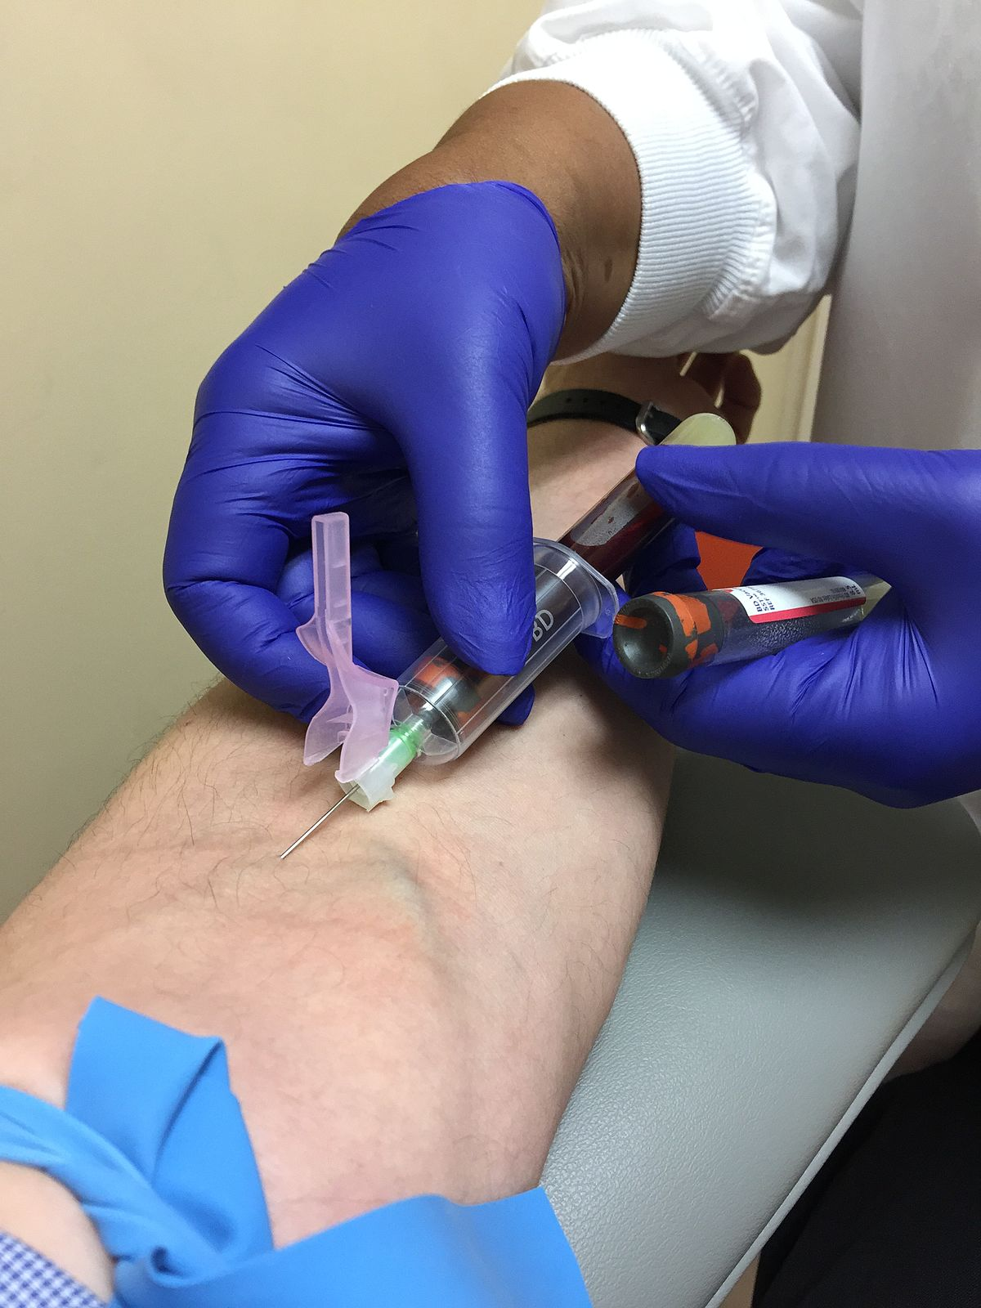
Procedure

- Ensure all required equipment is gathered to perform the procedure. This can include a clean tray containing equipment, tourniquet (single use where possible), swab to clean the area, 21-gauge multiple sample safety needle, vacutainer, appropriate vacuumed specimen tubes (check expiry dates), sterile adhesive plaster or hypoallergenic tape (check the service user’s allergy status when selecting dressings), specimen request form/s, non‐sterile, well‐fitting gloves, plastic apron, and sharps bin.
- Confirm the identification of the service user and explain and discuss the procedure with them and allow them time to ask questions. Where appropriate, discuss any problems which have arisen with venepuncture previously.
- Obtain verbal consent to proceed. If the service user lacks capacity, make sure an MCA/BI has been completed and remains relevant and valid.
- Assist the service user to find a comfortable and stable position to rest.
- Perform hand hygiene and put on clean gloves and prepare the equipment necessary for venepuncture on the clean tray.
- Perform a visual check of the service user’s veins, starting with those in the anti-cubital
fossa, looking for a prominent vein that runs under the skin surface that is easy to
palpate, assessing the size, depth, and condition according to the amount of blood
required. Peripheral veins in the hands and feet should be the last choice for
venepuncture, as they are painful for the service user.
- Place and support the service user’s arm on a clean pillow and apply a tourniquet to the upper arm on the chosen side, making sure that it does not obstruct arterial flow. If the radial pulse cannot be palpated, then the tourniquet is too tight.
- Observe and palpate for a dilated vein. If the tourniquet does not improve venous
access, the following methods can be used to improve venous access. Either:
  - Place the arm in a dependent position with the palm facing upwards and ask them to gently clench their fist, or
  - Tap or gently stroke the vein.
- Clean the service user's skin carefully for 30 seconds and allow to air dry for 30 seconds. Remove the cover from the needle, reassure the service user and anchor the vein by applying manual traction on the skin a few centimetres below the proposed insertion site.
- Insert the needle smoothly at an angle of approximately 30°.
- Slightly advance the needle into the vein, if possible, to stabilise its position.
- Take care not to place any pressure on the needle itself and withdraw the required amount of blood using vacuumed blood collection specimen tubes.
- Release the tourniquet if not already done. Remove the last sample tube from the
vacutainer tube. Place a swab over the puncture point and remove the needle but do not
apply pressure until the needle has been fully removed from the vein.
- Activate the needle safety device to prevent sharps injury and then discard the needle immediately into a sharps bin.
- Apply digital pressure directly over the puncture site until bleeding has ceased and, if able, the service user may apply continued pressure with a finger but should be discouraged from bending the arm.
- Gently invert the filled sample tubes at least six times or as directed for pertinent blood samples.
- Check and confirm service user details again before applying the printed labels to the blood bottles/handwritten relevant details on the blood bottle and arrange for delivery to the collection area for testing.

Post Procedure

- Perform a final check of the puncture point, confirm whether the service user is allergic to adhesive plasters.
- Apply an adhesive plaster or alternative dressing as indicated.
- Ensure that the service user is comfortable.
- Remove gloves and discard into the clinical waste and wash hands.
- Check the service user details that you have written on the blood bottles are identical to the request form before applying to the blood bottle/s. Similarly, if a request form was
not completed prior to the venepuncture, ensure the service user details match exactly with those on the sample bottle and document the procedure in the service users’ records.

Complications Associated with Venepuncture
Complications that may occur when venepuncture is performed may include arterial
puncture, injury to the surrounding nerves, formation of a haematoma, vaso-vagal attacks
and infection to the sample site.

Arterial Puncture
An arterial puncture can be identified by bright red blood, rapid pulsatile blood flow and
pain. The needle should be removed immediately, and pressure applied for 5 minutes by
the practitioner. A pressure dressing must be applied, and the service user should receive
advice to follow in the event of increased pain, swelling or loss of sensation.
No tourniquet or blood pressure cuff should be reapplied to the arm for 24 hours, and the incident should be documented in the service user's notes and recorded on an incident form, reported to the person in charge and an investigation commenced.

Nerve Injury
The practitioner should suspect an injury to the nerve if the service user complains of the
following; a sharp shooting pain, burning or electric shock (like sensation that radiates
down the arm which may be accompanied by altered sensation or numbness/tingling in
the fingers). In these circumstances, the needle should be removed immediately to
prevent further nerve damage. The service user should be advised, or staff must check that if the pain/numbness continues for more than a few hours, this must be reported to the person in charge for advice and guidance and the GP may need to be made aware. The incident should be documented in the service user's notes and an investigation commenced.

Haematoma
Haematoma formation is the commonest complication of venepuncture. A haematoma
develops when blood leaks from the vein into the surrounding tissues. It may be caused by
the needle penetrating completely through the vein wall, the needle only being partially
inserted, or because of applying insufficient pressure on the site when the needle is
removed. If a haematoma develops, the needle should be removed immediately, and pressure applied. In the event of a large haematoma developing, an ice pack can be applied to relieve pain and swelling. Any formation of a haematoma must be documented in the service user’s notes and the site monitored and documented over the next 48 hours or as directed by a medical practitioner.

Vaso–Vagal Episodes (Fainting)
Fainting may occur during or immediately following venepuncture. The service user may complain of feeling light‐headed and appear pale and sweaty. Loss of consciousness may occur
Suddenly, so the practitioner should be vigilant throughout the procedure and routinely
confirm with the service user that they do not feel unwell or faint. In the event of the service user feeling faint, the procedure should be abandoned immediately, pressure applied to the site and the service user should be encouraged to lay down/lower their head and breathe deeply.
If the Service user suffers a loss of consciousness, the practitioner should call for assistance
and ensure the service user's safety until they recover.

Infection
Infection at the venepuncture site is a rare occurrence. Aseptic technique should be
maintained with careful attention to hand washing and skin preparation. The venepuncture
site should not be re-palpated after cleaning and the site should be kept covered after being
bled. For any suspected infection, medical assistance should be sought.

Any pictures used are only for example purposes.

Service Specific Information
Where is the equipment for venepuncture stored?
Who is responsible for maintaining the stock?
Have nursing staff completed a competency assessment around venepuncture?

5. Equality Impact Assessment

Equality Impact Assessment Checklist |  | Yes/No? | Comments
1. | Does the procedural document affect one group less or more favorably than another on the basis of:
 | - Race? | No
 | - Ethnic origins (including gypsies and travelers)? | No
 | - Nationality? | No
 | - Gender? | No
 | - Culture? | No
 | - Religion or belief? | No
 | - Sexual orientation, including lesbian, gay and bisexual people? | No
 | - Age? | No
2. | Is there any evidence that some groups are affected differently? | No
3. | If you have identified potential discrimination, are there any exceptions valid, legal and/or justifiable? | N/A
4. | Is the impact of the procedural document likely to be negative? | No
5. | If so, can the impact be avoided? | N/A
6. | What alternatives are there to achieving the procedural document without the impact? | N/A
7. | Can we reduce the impact by taking different action? | N/A

If you have identified a potential discriminatory impact of this procedural document or need advice, please document the action required to avoid/reduce this impact.

