Urine Testing and Recognition of a Urine Infection
This document is uncontrolled when downloaded or printed.

Copyright © Care4Quality Ltd. All rights reserved.

Reference Number | REGCP09
Version | 1
Author | D. Martin
Owned by:
Date ratified:
Ratified by:
(Signed)
Issue Date
Review Date
(Signed)
Target Audience | Registered Managers, Registered Nurses, Care Team

1 | Purpose and Application
2 | Responsibilities
3 | Legislation and Regulation
4 | Urine Testing and Recognition of a Urinary Infection: Policy & Procedure
5 | Equality Impact Assessment
Contents
- Purpose & Application

This policy has been developed to provide guidance and information about urine testing and signs and symptoms of a urine infection, covering:

Urinalysis
When is a urine test needed?
How is a urine test done?
What can a urine test reveal?
Microscopic analysis
Urinalysis and dementia

The policy will apply to:

- Permanent employees
- Temporary employees
- Agency workers

It will be the responsibility of the managers to take any necessary action if this policy is not adhered to, taking into account the relevant regulatory responsibility.

- Responsibilities

The nominated individual is accountable for the implementation of this policy in its entirety. They are a key contact for the service.

The registered manager and any trained nurses are responsible for the implementation of this policy, and to evidence training in recognition and treatment of a urine infection.

Any care staff that have had training and are aware of how to support a service to obtain a sample of urine for testing and to recognise the signs and symptoms of a urine infection.

- Legislation and Regulation

Health and Social Care Act 2008 (Regulated Activities) Regulations 2014: Regulation 12

The intention of this regulation is to prevent people from receiving unsafe care and treatment and prevent avoidable harm or risk of harm. Providers must assess the risks to people's health and safety during any care or treatment and make sure that staff have the qualifications, competence, skills and experience to keep people safe.

Providers must make sure that the premises and any equipment used is safe and where applicable, available in sufficient quantities.
Providers must prevent and control the spread of infection. Where the responsibility for care and treatment is shared, care planning must be timely to maintain people's health, safety and welfare.

CQC understands that there may be inherent risks in carrying out care and treatment, and they will not consider it to be unsafe if providers can demonstrate that they have taken all reasonable steps to ensure the health and safety of people using their services and to manage risks that may arise during care and treatment.

CQC can prosecute for a breach of this regulation or a breach of part of the regulation if a failure to meet the regulation results in avoidable harm to a person using the service or if a person using the service is exposed to significant risk of harm. They do not have to serve a Warning Notice before prosecution.

- Urine Testing and Recognition of a Urinary Infection: Policy & Procedure

Urine Testing (Urinalysis)
A urinalysis is a simple test that looks at a small sample of urine. It can help find problems that need treatment, including infections or kidney problems. It can also help find serious diseases in the early stages, like kidney disease, diabetes, or liver disease.

A urine test can include three parts:

Visual Examination: the urine will be looked at for colour and clearness. Blood may make urine look red or the colour of tea or cola. An infection may make urine look cloudy. Foamy urine can be a sign of kidney problems.

Microscopic Examination: a small amount of urine will be looked at under a microscope to check for things that do not belong in normal urine which cannot be seen with the naked eye, including red blood cells, white blood cells (or pus cells), bacteria (germs), or crystals (which are formed from chemicals in the urine and may eventually get bigger and become kidney stones).

Dipstick Test: a dipstick is a thin, plastic stick with strips of chemicals on it. It is dipped into the urine. The strips change color if a substance is present at a level that is above normal.

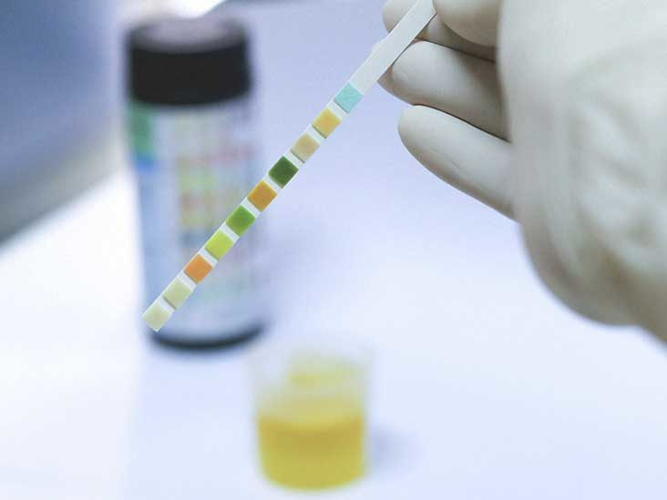
When a Urine Test Needed?
Urine tests are very useful for providing information to assist in the diagnosis, monitoring and treatment of a wide range of diseases.

Urine can also be tested for a variety of substances relating to drug abuse, both as part of rehabilitation programmes and in the world of professional sport.

The urine can be tested very quickly using a strip of special paper, which is dipped in the urine just after urination. This will show if there are any abnormal products in the urine such as sugar, protein or blood. If more tests are needed to get more details, the urine will be analysed at a laboratory.

How is a Urine Test Done?
If staff suspect a case of cystitis (infection of the bladder), a sample of urine can be sent to the laboratory for culture, which will confirm the type of bacteria present and which antibiotics are best for treating the infection.

Urine is normally sterile, but it can get contaminated through bacteria on the skin and the genitals on its way out. For this reason, it is very important for men to pull back their foreskin and wash their penis before the sample is taken, whereas women should wash around the entrance to their vagina before providing a sample.

It is also important that the woman keeps her labia (vaginal lips) separated during urination, so that the urine does not get contaminated with bacteria from the skin and the vagina.

Adults who do not have difficulty passing urine on demand can take the sample by urinating first in the toilet, then a little into a sterile specimen container (obtained from the GP) and then the rest in the toilet. This gives what is known as a midstream specimen.

What can a Urine Test Reveal?
A urine test checks different components of urine, including a waste product made by the kidneys. A regular urine test may be done to help find the cause of symptoms. The test can give information about your health and problems there may be.

The kidneys take out waste material, minerals, fluids, and other substances from the blood to be passed in the urine. Urine has hundreds of different bodily wastes. What we eat, drink, how much we exercise, and how well the kidneys work can affect what is in the urine.

A regular urinalysis often includes the following tests.

- Colour. Many things affect urine colour, including fluid balance, diet, medicines, and diseases. How dark or light the colour is an indication of how much water is in it. Vitamin B supplements can turn urine bright yellow. Some medicines, blackberries, beets, rhubarb, or blood in the urine can turn urine red-brown.
- Clarity. Urine is normally clear. Bacteria, blood, sperm, crystals, or mucus can make urine look cloudy.
- Odour. Urine does not smell very strong but has a slightly "nutty" odour. Some diseases cause a change in the odour of urine. For example, an infection with E. coli bacteria can cause a bad odor, while diabetes or starvation can cause a sweet, fruity odour.
- Specific Gravity. This checks the amount of substances in the urine. It also shows how well the kidneys balance the amount of water in urine. The higher the specific gravity, the more solid material is in the urine. When we drink a lot of fluid, kidneys make urine with a high amount of water in it which has a low specific gravity. When not enough fluid is taken, kidneys make urine with a small amount of water in it which has a high specific gravity.
- pH. The pH is a measure of how acidic or alkaline (basic) the urine is. A urine pH of 4 is strongly acidic, 7 is neutral (neither acidic nor alkaline), and 9 is strongly alkaline. Sometimes the pH of urine is affected by certain treatments.
- Protein. Protein is normally not found in the urine. Fever, hard exercise, pregnancy, and some diseases, especially kidney disease, may cause protein to be in the urine.
- Glucose. Glucose is the type of sugar found in blood. Normally there is very little or no glucose in urine. When the blood sugar level is very high, as in uncontrolled diabetes, the sugar spills over into the urine. Glucose can also be found in urine when the kidneys are damaged or diseased.
- Nitrites. Bacteria that cause a urinary tract infection (UTI) make an enzyme that changes urinary nitrates to nitrites. Nitrites in urine show a UTI is present.
- Leukocyte Esterase (WBC Esterase). Leukocyte esterase shows leukocytes (white blood cells [WBCs]) in the urine. WBCs in the urine may mean a UTI is present.
- Ketones. When fat is broken down for energy, the body makes substances called ketones (or ketone bodies). These are passed in the urine. Large amounts of ketones in the urine may mean a very serious condition is present, such as diabetic ketoacidosis. A diet low in sugars and starches (carbohydrates), starvation, or severe vomiting may also cause ketones to be in the urine.
- Microscopic Analysis. In this test, urine is spun in a special machine (centrifuge) so the solid materials (sediment) settle at the bottom. The sediment is spread on a slide and looked at under a microscope. Things that may be seen on the slide include:
- Red or white blood cells. Blood cells are not found in urine normally. Inflammation, disease, or injury to the kidneys, ureters, bladder, or urethra can cause blood in urine. Strenuous exercise, such as running a marathon, can also cause blood in the urine. White blood cells may be a sign of infection or kidney disease.
- Casts. Some types of kidney disease can cause plugs of material (called casts) to form in tiny tubes in the kidneys. The casts then get flushed out in the urine. Casts can be made of red or white blood cells, waxy or fatty substances, or protein. The type of cast in the urine can help show what type of kidney disease may be present.
- Crystals. Healthy people often have only a few crystals in their urine. A large number of crystals, or certain types of crystals, may mean kidney stones are present or there is a problem with how the body is using food (bacteria, yeast cells, or parasites). There are no bacteria, yeast cells, or parasites in urine normally. If these are present, it can mean you have an infection.
- Squamous Cells. The presence of squamous cells may mean that the sample is not as pure as it needs to be. These cells do not mean there is a medical problem, but another sample may be requested.

Common Causes of Urine Discolouration

Colour | Pathological Causes | Food and Drug Causes
Brown | Bile pigments, myoglobin | Levodopa, metronidazole, nitrofurantoin, some antimalarial agents, fava beans
Brownish-Black | Bile pigments, melanin, methaemoglobin | Cascara, levodopa, methyldopa, senna, Amitriptyline, indigo carmine,  IV cimetidine, IV promethazine,  Methylthioninium chloride, triamterene
Green or Blue | Pseudomonal urinary tract infection (UTI), biliverdin
Orange | Bile pigments | Phenothiazines, phenazopyridine
Red | Haematuria, haemoglobinuria,  Myoglobinuria, porphyria | Beets, blackberries, rhubarb, phenolphthalein, rifampicin
Yellow | Concentrated urine (orange to gold in dehydration) | Carrots, cascara.

Urinary Tract Infections and Dementia
UTIs can cause sudden confusion in older people and people with dementia. If the person has a sudden and unexplained change in their behaviour, such as increased confusion, agitation, or withdrawal, this may be because of a UTI. The person may not be able to communicate how they feel, therefore it is important that staff are familiar with the symptoms of UTIs and seek medical help to ensure they get the correct treatment so all infections should be identified and treated quickly. For people who do not have capacity, the principles of the mental capacity act must be considered in line with a best interest decision.

All pictures are for example only and may appear different when prescribed.

Service Specific Information
Where are urine test strips stored?
Where are urine capture bottles stored?
Who would be responsible for ensuring that the sample gets sent/delivered to the GP surgery?
Who is responsible for the follow-up of any results and medications prescribed? Is any follow-up required?
Who is responsible for updating the care plan and risk assessment, if required?

5. Equality Impact Assessment

Equality Impact Assessment Checklist |  | Yes/No? | Comments
1. | Does the procedural document affect one group less or more favourably than another on the basis of:
 | - Race? | No
 | - Ethnic origins (including gypsies and travelers)? | No
 | - Nationality? | No
 | - Gender? | No
 | - Culture? | No
 | - Religion or belief? | No
 | - Sexual orientation, including lesbian, gay and bisexual people? | No
 | - Age? | No
2. | Is there any evidence that some groups are affected differently? | No
3. | If you have identified potential discrimination, are there any exceptions valid, legal and/or justifiable? | N/A
4. | Is the impact of the procedural document likely to be negative? | No
5. | If so, can the impact be avoided? | N/A
6. | What alternatives are there to achieving the procedural document without the impact? | N/A
7. | Can we reduce the impact by taking different action? | N/A

If you have identified a potential discriminatory impact of this procedural document or need advice, please document the action required to avoid/reduce this impact.

