Blood Pressure
This document is uncontrolled when downloaded or printed.

Copyright © Care4Quality Ltd. All rights reserved.

Reference Number | REGCP02
Version | 1
Author | H. Fuller
Owned by:
Date ratified:
Ratified by:
(Signed)
Issue Date
Review Date
(Signed)
Target Audience | Registered Managers, Registered Nurses, Care Team

Contents
1 | Purpose and Application
2 | Responsibilities
3 | Legislation and Regulation
4 | Blood Pressure: Policy & Procedure
5 | Equality Impact Assessment

- Purpose & Application

This policy has been developed to provide guidance and information about blood pressure, covering:

What is blood pressure?
How is blood pressure measured?
How to take someone’s blood pressure using a machine
Hypertension (high blood pressure)
Hypotension (low blood pressure)

The policy will apply to:

- Permanent employees
- Temporary employees
- Agency workers

It will be the responsibility of the managers to take any necessary action if this policy is not adhered to, taking into account the relevant regulatory responsibility.

- Responsibilities

The nominated individual is accountable for the implementation of this policy in its entirety. They are a key contact for the service.

The registered manager and any trained nurses are responsible for the implementation of this policy.

Any care staff that have had a competency assessment in taking and interpreting blood pressure readings.

- Legislation and Regulation

Health and Social Care Act 2008 (Regulated Activities) Regulations 2014: Regulation 12

The intention of this regulation is to prevent people from receiving unsafe care and treatment and prevent avoidable harm or risk of harm. Providers must assess the risks to people's health and safety during any care or treatment and make sure that staff have the qualifications, competence, skills, and experience to keep people safe.

Providers must make sure that the premises and any equipment used is safe and where applicable, available in sufficient quantities. Medicines must be supplied in sufficient quantities, managed safely, and administered appropriately to make sure people are safe.
Providers must prevent and control the spread of infection. Where the responsibility for care and treatment is shared, care planning must be timely to maintain people's health, safety, and welfare.

CQC understands that there may be inherent risks in carrying out care and treatment, and we will not consider it to be unsafe if providers can demonstrate that they have taken all reasonable steps to ensure the health and safety of people using their services and to manage risks that may arise during care and treatment.

CQC can prosecute for a breach of this regulation or a breach of part of the regulation if a failure to meet the regulation results in avoidable harm to a person using the service or if a person using the service is exposed to significant risk of harm. CQC do not have to serve a Warning Notice before prosecution.

- Blood Pressure: Policy & Procedure

What is Blood Pressure?
Blood pressure is a measure of the force that your heart uses to pump blood around your body.

How is Blood Pressure Measured?
Blood pressure is measured in millimetres of mercury (mmHg) and is given as 2 figures:

- Systolic pressure: the pressure when your heart pushes blood out.
- Diastolic pressure: the pressure when your heart rests between beats.

For example, if your blood pressure is “140 over 90” or 140/90mmHg, it means you have a systolic pressure of 140mmHg and a diastolic pressure of 90mmHg.
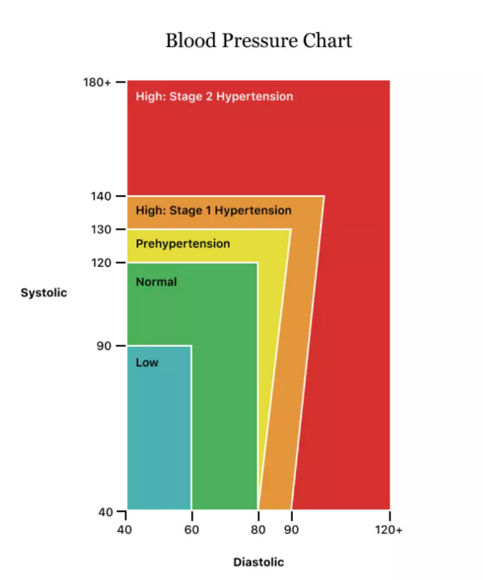
As a general guide:

- Ideal blood pressure is considered to be between 90/60mmHg and 120/80mmHg.

- High blood pressure is considered to be 140/90mmHg or higher

- Low blood pressure is considered to be 90/60mmHg or lower

How to Take Someone’s Blood Pressure Using a Machine

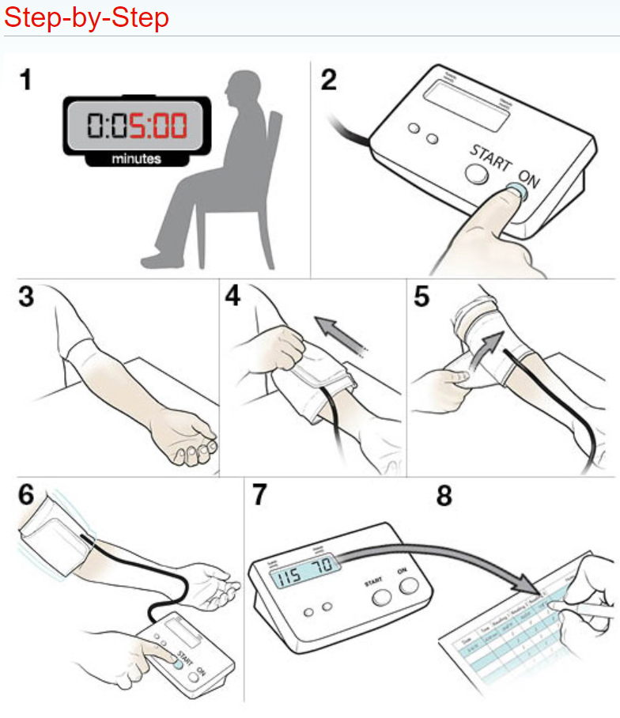

** Please ensure that you record the reading accurately and legibly in the appropriate place (i.e. care plan, record chart, MAR chart etc.) **

Hypertension (High Blood Pressure)
Hypertension is persistently raised arterial blood pressure. It increases the risk of a number of conditions, including heart failure, coronary artery disease, stroke, chronic kidney disease, peripheral arterial disease, and vascular dementia.

Primary hypertension (which occurs in about 90% of people) has no identifiable cause.
Secondary hypertension (about 10% of people) has a known underlying cause, such as renal, endocrine, or vascular disorder, or the use of certain drugs.

Hypertension should be suspected if clinic systolic blood pressure is sustained above or equal to 140 mmHg, or diastolic blood pressure is sustained above or equal to 90 mmHg, or both. The diagnosis is then confirmed with ambulatory blood pressure monitoring (ABPM) or home blood pressure monitoring (HBPM).

Hypertension is classified according to severity:

- Stage 1 hypertension: blood pressure ranging from 140/90 mmHg to 159/99 mmHg and subsequent ABPM daytime average or HBPM average blood pressure ranging from 135/85 mmHg to 149/94 mmHg.
- Stage 2 hypertension: blood pressure of 160/100 mmHg or higher but less than 180/120 mmHg and subsequent ABPM daytime average or HBPM average blood pressure of 150/95 mmHg or higher.
- Stage 3 or severe hypertension: systolic blood pressure of 180 mmHg or higher or clinic diastolic blood pressure of 120 mmHg or higher.
- Accelerated (or malignant) hypertension is a severe increase in blood pressure to 180/120 mmHg or higher (and often over 220/120 mmHg) with signs of retinal haemorrhage and/or papilledema (swelling of the optic nerve).

Urgent GP Referral should be arranged for people with:
- A blood pressure of 180/120 mmHg and higher with signs of retinal haemorrhage or papilledema (accelerated hypertension) or life-threatening symptoms, such as new onset confusion, chest pain, signs of heart failure, or acute kidney injury.
- Suspected pheochromocytoma, for example labile or postural hypotension, headache, palpitations, pallor, abdominal pain, or diaphoresis.

Hypotension (Low Blood Pressure)
A blood pressure reading lower than 90 mmHg for the top number (systolic) or 60 mmHg for the bottom number (diastolic) is generally considered low blood pressure.

The causes of low blood pressure can range from dehydration to serious medical disorders. It is important to find out what is causing the low blood pressure so that it can be treated.

Symptoms of Low Blood Pressure
For some people, low blood pressure signals an underlying problem, especially when it drops suddenly or is accompanied by signs and symptoms such as:

- Dizziness or lightheadedness
- Fainting
- Blurred or fading vision
- Nausea
- Fatigue
- Lack of concentration
- Shock
- Extreme hypotension can result in this life-threatening condition. Signs and symptoms include:
- Confusion, especially in older people
- Cold, clammy, pale skin
- Rapid, shallow breathing
- Weak and rapid pulse

If the resident has signs or symptoms of shock, seek emergency medical help.

Causes of Low Blood Pressure

Heart problems. Some heart conditions that can lead to low blood pressure include extremely low heart rate (bradycardia), heart valve problems, heart attack and heart failure.

Endocrine problems. Thyroid conditions such as parathyroid disease, adrenal insufficiency (Addison's disease), low blood sugar (hypoglycemia) and, in some cases, diabetes can trigger low blood pressure.

Dehydration. When your body loses more water than it takes in, it can cause weakness, dizziness, and fatigue. Fever, vomiting, severe diarrhoea, overuse of diuretics and strenuous exercise can lead to dehydration.

Blood loss. Losing a lot of blood, such as from a major injury or internal bleeding, reduces the amount of blood in your body, leading to a severe drop in blood pressure.

Severe infection (septicemia). When an infection in the body enters the bloodstream, it can lead to a life-threatening drop in blood pressure called septic shock.

Severe allergic reaction (anaphylaxis). Common triggers of this severe and potentially life-threatening reaction include foods, certain medications, insect venoms and latex. Anaphylaxis can cause breathing problems, hives, itching, a swollen throat, and a dangerous drop in blood pressure.

Lack of nutrients in your diet. A lack of Vitamin B-12, folate and iron can keep your body from producing enough red blood cells (anemia), causing low blood pressure.

Medications that Can Cause Low Blood Pressure

- Water pills (diuretics), such as furosemide (Lasix) and hydrochlorothiazide (Microzide, plus others).
- Alpha blockers, such as prazosin (Minipress).
- Beta blockers, such as atenolol (Tenormin) and propranolol (Inderal, Innopran XL, plus others).
- Drugs for Parkinson's disease, such as pramipexole (Mirapex) or those containing levodopa.
- Certain types of antidepressants (tricyclic antidepressants), including doxepin (Silenor) and imipramine (Tofranil).
- Drugs for erectile dysfunction, including sildenafil (Revatio, Viagra) or tadalafil (Adcirca, Alyq, Cialis), particularly when taken with the heart medication nitroglycerin (Nitrostat, plus others).

Low Blood Pressure on Standing Up (Orthostatic or Postural Hypotension)
This is a sudden drop in blood pressure when you stand up from a sitting position or after lying down. Gravity causes blood to pool in your legs when you stand. Ordinarily, your body compensates by increasing your heart rate and constricting blood vessels, thereby ensuring that enough blood returns to your brain. However, in people with orthostatic hypotension, this compensating mechanism fails, and blood pressure falls, leading to dizziness, lightheadedness, blurred vision and even fainting.

Orthostatic hypotension can occur for various reasons, including dehydration, prolonged bed rest, pregnancy, diabetes, heart problems, burns, excessive heat, large varicose veins, and certain neurological disorders.

A number of medications can also cause orthostatic hypotension, particularly drugs used to treat high blood pressure, such as diuretics, beta blockers, calcium channel blockers and angiotensin-converting enzyme (ACE) inhibitors, as well as antidepressants and drugs used to treat Parkinson's disease and erectile dysfunction.

Orthostatic hypotension is especially common in older adults, but it also affects young, otherwise healthy people who stand up suddenly after sitting with their legs crossed for long periods or after squatting for a time.

Low Blood Pressure After Eating (Postprandial Hypotension)
This drop in blood pressure occurs one to two hours after eating and affects mostly older adults.
Blood flows to your digestive tract after you eat. Ordinarily, your body increases your heart rate and constricts certain blood vessels to help maintain normal blood pressure. However, in some people these mechanisms fail, leading to dizziness, faintness, and falls.

Postprandial hypotension is more likely to affect people with high blood pressure or autonomic nervous system disorders such as Parkinson's disease.

Eating small, low-carbohydrate meals, drinking more water and avoiding alcohol might help reduce symptoms.

Low Blood Pressure due to nervous System Damage (Multiple System Atrophy with Orthostatic Hypotension)
Also called Shy-Drager syndrome, this rare disorder has many Parkinson disease-like symptoms. It causes progressive damage to the autonomic nervous system, which controls involuntary functions such as blood pressure, heart rate, breathing and digestion. It is associated with having very high blood pressure while lying down.

Service Specific Information
Where is the blood pressure monitor kept when not in use?

- Equality Impact Assessment

Equality Impact Assessment Checklist |  | Yes/No? | Comments
1. | Does the procedural document affect one group less or more favourably than another on the basis of:
 | - Race? | No
 | - Ethnic origins (including gypsies and travelers)? | No
 | - Nationality? | No
 | - Gender? | No
 | - Culture? | No
 | - Religion or belief? | No
 | - Sexual orientation, including lesbian, gay and bisexual people? | No
 | - Age? | No
2. | Is there any evidence that some groups are affected differently? | No
3. | If you have identified potential discrimination, are there any exceptions valid, legal and/or justifiable? | N/A
4. | Is the impact of the procedural document likely to be negative? | No
5. | If so, can the impact be avoided? | N/A
6. | What alternatives are there to achieving the procedural document without the impact? | N/A
7. | Can we reduce the impact by taking different action? | N/A
If you have identified a potential discriminatory impact of this procedural document or need advice, please document the action required to avoid/reduce this impact.

