Covid 19 – Vaccination Policy – Care Home
This document is uncontrolled when downloaded or printed.

Copyright © Care4Quality Ltd. All rights reserved.

Reference Number | REG12-CV01
Version | 1
Author | H.Fuller
Owned by:
Date ratified:
Ratified by:
(Signed)
Issue Date
Review Date
(Signed)
Target Audience | Registered Managers, Registered Nurses, Care Team

1 | Purpose & Application
2 | Responsibilities
3 | The Policy
4 | General Guidance on Demonstrating Evidence
5 | Service Specific Information
6 | Equality Impact Assessment
Contents
- Purpose & Application

This policy has been produced to help support the implementation of the Health and Social Care Act 2008 (Regulated Activities) (Amendment) (Coronavirus) Regulations 2021 (‘the Regulations’). These regulations require registered persons of all Care Quality Commission (CQC) registered care homes (which provide accommodation together with nursing or personal care) to ensure that a person does not enter the indoor premises unless they have been vaccinated. This is subject to certain exemptions.

The regulations were laid in Parliament on 22 June 2021 and were made on 22 July 2021.
It will be the responsibility of managers to take any necessary action if this policy is not adhered to, taking into account the relevant regulatory responsibility.
The guidance is aimed at service providers, registered persons, local authorities, workers (including agency staff) and residents of CQC-regulated care homes which provide accommodation for persons who require nursing and personal care.
This guidance also applies to all professionals and tradespeople who enter these settings.
- Responsibilities

The nominated individual is accountable for the implementation of this policy in its entirety. They are a key contact for the service.
The registered manager and any trained nurses are responsible for the implementation of this policy.
Any care staff that have had a competency assessment in the use and administration of oxygen either by cylinder or concentrator.

- The Policy

Summary of the regulations
The regulations require that all CQC-registered service providers (or registered managers) of accommodation for those who require nursing or personal care in a care home must ensure that a person does not enter the care home unless:

- the person resides in the care home used by the registered person (a resident) – ‘registered person’ means person registered with the CQC as a manager or service provider in respect of a regulated activity – in this case, the regulated activity for the provision of accommodation for persons requiring nursing or personal care
- the person has provided the registered person (or those acting on behalf of the registered person) with satisfactory evidence that:
- they have been vaccinated with the complete course of an authorised vaccine (the individual can prove they are fully vaccinated)
- they, for clinical reasons, should not be vaccinated (the individual is exempt for medical reasons) – further detail below
- it is reasonably necessary for the person to provide emergency assistance in the care home (further detail below)
- it is reasonably necessary for the person to provide urgent maintenance assistance to the care home (further detail below)
- the person is a member of the emergency services in execution of their duties (further detail below)
- the person is a friend or relative of the resident visiting the resident (further detail below – this also includes unpaid carers or designated essential care givers)
- the person is visiting a resident who is dying (further detail below)
- it is reasonably necessary for the person to provide comfort or support to a resident in relation to a resident’s bereavement following the death of a relative or friend (further detail below)
- the person is under the age of 18 (further detail below)

The vaccination requirement only applies to people who go inside a care setting (the definition of ‘care home’ does not include any surrounding grounds). As long as someone is not entering the building, they would not need to show vaccination status.

Registered persons

The registered person is responsible for ensuring that everyone who enters their care home is either vaccinated or exempt. The registered person will be the person registered with the CQC as a manager or service provider.

Registered persons may decide for another person to carry out certain tasks to help comply with the regulations. While this is acceptable, the registered person is the one who remains legally responsible for compliance with the regulations.

Booster doses
Booster doses are not currently included in the regulations, but managers are strongly advised to encourage workers to take up booster vaccines if eligible, and a provision for booster vaccines may be added to the regulations in the future.

Residents
If someone is a resident or being admitted as a resident, they and an accompanying friend or relative will not require proof of vaccination.
We will, however, continue to encourage people living in care homes to take up vaccination as soon as possible, building on the repeat visits that NHS colleagues have already made to care homes.
The regulations require prospective residents and their families visiting care homes to provide evidence of vaccination or medical exemption. Care home managers may want to consider remote visits via video link for any prospective residents who are not vaccinated. We will monitor the impact of this restriction for prospective residents.
Emergency assistance
If someone is entering the care home for emergency assistance for an incident in the care home itself, or in relation to an incident in a neighbouring building (for example if access is required to respond to a fire), they will not need to show proof of vaccination or medical exemption.

It is the registered person’s responsibility to use their professional judgement to determine whether a situation is an emergency in line with the guidance set out below. Registered persons will be expected to keep a log of all emergency situations, including details of the circumstances, during which people entered the home without showing proof of vaccination or exemption.

An emergency situation could include (but is not limited to):
- members of the public assisting in the event of flood or fire
- social workers responding to immediate safeguarding concerns

Emergency services

In addition to providing emergency assistance, emergency services staff attending the care home in the execution of their duties are exempt from the requirement.

This includes:
- members of the fire and rescue services attending the care home to execute their duties
- members of the police service attending the care home to execute their duties
- members of the health service deployed for emergency response
- Friends, relatives and essential care givers
- Friends, family (who also may be unpaid carers) and essential care givers will not need to show proof of vaccination or medical exemption.

Visits from family and friends are vital for the health and wellbeing of people living in care homes. It would be unjustifiably detrimental to residents to deprive them of contact with, and care from, their loved ones.

Urgent maintenance work
If work is only being done outside the care home and individuals carrying out maintenance do not need to enter the care home, then these individuals do not need to show proof of vaccination or medical exemption.

If work is required inside the care home, then individuals carrying out maintenance will need to show proof of vaccination or medical exemption.

However, if urgent maintenance work is required in the event of a risk to life or continuity of care, workers are exempt from these requirements. This could include (but is not limited to):

- failure or breakdown of the gas, electricity or water supply
- dangerous electrical fault
- serious damage caused by fire, flood, storm or explosion
- burst water service
- serious roof leak
- gas leak
- any fault or damage in the care home that makes the care home unsafe or insecure
- a serious fault in a lift or staircase

It is the manager’s responsibility to use their professional judgement to determine whether a situation requires urgent maintenance work. Managers will be expected to keep a log of all urgent maintenance work during which people entered the home without showing proof of vaccination or medical exemption, and a short description of the incident for record keeping purposes.

Death and bereavement

People do not need to show proof of vaccination or exemption if they are visiting a resident who is dying (that is in their last days of life) or they are providing comfort or support to a resident following the death of a relative or friend.

Those performing spiritual rituals for a resident would therefore also not need to show proof of vaccination status.

Funeral directors and their staff will have to show proof of vaccination or exemption when entering the care home.

Under 18s

A person under the age of 18 does not have to provide evidence of vaccination or exemption before entering a care home.

Visiting professionals who are under 18 will be able to enter the care home without showing proof of vaccination status but may need to demonstrate proof that they are under 18. As soon as they turn 18, they will not be able to enter the residence until they have had a full course of an MHRA approved COVID-19 vaccine.

Students

All students who enter the care residence as part of their studies will need to show proof of vaccination or exemption, unless they are under 18 or visiting as family or a friend of a resident.

Volunteers

All volunteers who enter the care residence will need to show proof of vaccination or exemption, unless they are under 18.

Staff travelling from non-care settings
Anyone who enters a care home as part of their professional responsibilities will need to show proof of vaccination unless they are exempt. Therefore, staff (such as trainers) who normally work in non-care settings (such as in the company headquarters) will still need to be vaccinated if they enter a care home. This also includes staff who may work in the home on a part-time or occasional basis, to deliver non-care-related services, such as hairdressing, maintenance, or activities.

Entering a care home for a job interview

Anyone who enters a care home for a job interview must show proof of vaccination unless they are exempt.
If someone intends to have the vaccination but is not yet vaccinated, the interview should take place outside of the care home or remotely (via video call or telephone).

Recruitment of new staff

The regulations also apply to new staff recruited by the registered provider. It is important to note that only new recruits that have had a full course of an MHRA approved COVID-19 vaccine or are medically exempt from the requirement are eligible to work in the care home.
Care homes should notify prospective staff of the requirement at the start of the application process and undertake appropriate checks, during the recruitment process, to ensure the individual is eligible to work in the care home. It will only be possible for a newly appointed member of staff to start working in the care home once they have provided evidence of their vaccination status or a medical exemption.

Making postal, courier or other deliveries and collections

The requirement only applies to those entering the inside of a care home. As long as someone is not entering the building, those people making postal, courier or other deliveries or collections would not need to show proof of their vaccination or medical exemption.
If, for example, a postal employee must enter the inside of the care home, as the package is too heavy or large for a staff member to lift, then they must show proof of vaccination or exemption.

4. General guidance on demonstrating evidence

Required evidence

In order to enter a care home, individuals must be able to demonstrate that they have received a complete course of their COVID-19 vaccination, unless exemptions apply.

The registered person (or those acting on behalf of the registered person) at the care home needs to satisfy themselves of the identity of the person entering the care home and their proof of vaccination.

How to demonstrate evidence of vaccination

NHSX are considering how the NHS COVID Pass service could be used to support registered persons and staff to check and demonstrate vaccine status. In the interim, registered persons can choose to use the existing NHS COVID Pass service to view an individual’s vaccination status.

Individuals that have been vaccinated by the NHS in England may demonstrate their vaccination status using the NHS COVID Pass service via the following 3 routes:

- the NHS App
- the NHS website – NHS.uk
- the NHS COVID Pass letter

An individual’s NHS appointment card cannot be used as proof of vaccination status.
NHS App

An individual’s vaccination status can be found within the NHS COVID Pass service of the NHS App.

The registered person (or those acting on the behalf of the registered person) would be able to take this as proof of the individual’s vaccination status to verify that they have had a complete course of a COVID-19 vaccination.

General guidance on medical exemptions

For a small number of people vaccination is not appropriate due to clinical reasons. These people will be able to seek a clinically approved exemption from this requirement. Currently staff will need to consult with their GP and request proof of medical exemption.

Other measures to reduce risk of transmission

It is important that all those entering care homes, including those who are exempt from vaccination, continue to follow infection prevention and control measures, including the correct usage of PPE, to reduce the risk of transmission. However, these measures are not a substitution for the requirement for individuals to be fully vaccinated, which applies to all persons entering a care home unless exempt.

A risk assessment should be undertaken for those who are exempt from vaccination, to reduce risk of transmission. This might include a change to their duties where such a change is appropriate. It should also be considered that those that are exempt from vaccination may also be in the clinically extremely vulnerable category.

Checking vaccination or exemption status

Registered persons (or those acting on behalf of the registered person) will have to check that all persons wishing to enter the care home have received a full course of vaccination, unless they are exempt. This includes checking, for example, care home staff, health care professionals, CQC inspectors, tradespeople, hairdressers and beauticians.

The requirement only applies in respect of persons entering the inside of the care home premises and it will be up to the registered person (or those acting on behalf of the registered person) to identify the most appropriate procedures to check vaccination status.
Compliance with the regulations would be an appropriate reason for not granting entry to a CQC inspector or another individual, unless they are exempt.

In cases where care homes have multiple buildings, care homes may prefer to have check points at the entrance of each building. Alternatively, registered persons may opt for there to be a single check point to ensure that all individuals are verified as being vaccinated or exempt before proceeding to access other buildings.

The guidance on demonstrating evidence section of this document outlines which forms of evidence are acceptable as evidence to demonstrate vaccination status. An individual’s NHS appointment card should not be accepted as sufficient evidence. We are aware some individuals will have been vaccinated outside of the UK. We are working on a solution to this and will provide further guidance on the acceptable evidence for this as soon as possible.

Recording vaccination or exemption status

The registered person should keep a record of:

- the vaccination or exemption status of staff members and the date that the status was last checked
- the vaccination or exemption status of those entering the care home unless exempt and the date that the status was last checked

There is no requirement for registered persons to record the clinical reason behind the exemption - they should only record whether a person is medically exempt or not.

Individuals entering a care home only need to demonstrate vaccination status on the first occasion they enter or register, and the registered person should record their status on the care home’s local system (for example IT system, paper file and so on).

All subsequent checks of individuals who have previously demonstrated vaccination status can be carried out via the records which will state the date and time the individual proved their status. Care homes will be able to use these records as proof of vaccination status, to reduce the burden of having to re-check every individual.

Care home managers can also decide to check more often, if preferred, but there is no requirement to do so. Records should be checked regularly to ensure they are up to date.
The registered person will be able share these records with CQC to demonstrate they have checked 3rd party medical exemptions.

Data protection principles

The regulations expressly state that a care home may process information about vaccination or medical exemption status, but this must be done in a way that is consistent with data protection legislation (see further below).

Keeping written records and General Data Protection Regulation (GDPR) compliance
Care homes must keep records to demonstrate compliance with the regulations.
Data protection impact assessments and appropriate policy documents will need to be reviewed and updated with any additional lawful basis under Art 6 UK GDPR and Art 9 UK GDPR identified for processing for this new process.

Data about vaccination or medical exemptions is health data and therefore special category data for the purposes of the data protection legislation including the Data Protection Act 2018 and the UK GDPR.

Ongoing monitoring

The monitoring of the requirement is the responsibility of CQC.
CQC propose to add the following question to the provider information return (PIR) once the regulations are in force:

‘How are you assured that those you employ and deploy within your service have had their mandatory vaccinations?’

CQC will also build a similar question into their monitoring approach once this duty is in place.

Inspection

On inspection, CQC will look for evidence to confirm systems and processes are in place to comply with the requirement.

Registered persons will not be required to show a record of the evidence itself but will need to provide assurance that systems and process are in place to ensure that individuals who enter the premises are fully vaccinated or exempt.

Registered persons may choose to make a record of the evidence they have seen for their own internal staff employment record keeping. If the evidence is collected and recorded, all personal data must be handled in accordance with UK GDPR. This includes providing individuals with privacy information at the stage their data is being collected. Please refer to the guidance from the Information Commissioner’s Office to ensure you have appropriate lawful basis, technical and security measures in place to protect personal data.

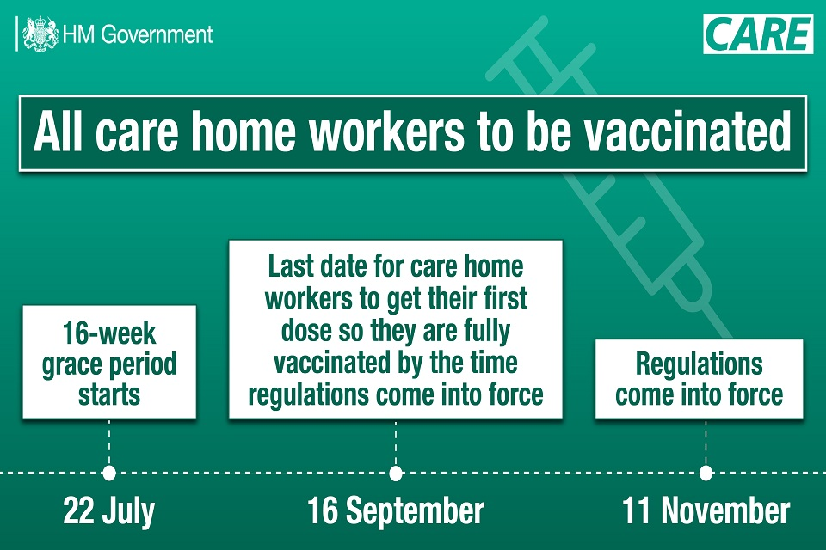

Key dates to bear in mind are:

22 July (this is when the grace period starts)
16 September (last date for care home workers to get their first dose so they are fully vaccinated by the time the regulations come into force)
11 November (regulations come into force)

4. Service Specific Information

Service Specific Information
Details
Are staff over 18 are entitled to time off work (with or without pay) to be vaccinated or obtain evidence of medical exemption?

When will the care home expect evidence of vaccination or exemption?
How will this evidence be logged and who will be responsible within the organisation for keeping this up to date?
What the arrangements relating to leave if staff experience side effects from vaccination.
How data about vaccination or exemption will be processed in line with GDPR
How will the care service assess vaccination requirements of new recruits and agency staff will be addressed

5. Equality Impact Assessment

Equality impact assessment checklist |  | Yes/No? | Comments
1. | Does the procedural document affect one group less or more favourably than  another on the basis of: | No | In order to be vaccinated, a person must have an NHS number. Support will be provided to people requiring help to access this information.
 | - Race? | No
 | - Ethnic origins (including gypsies and travellers)? | No
 | - Nationality? | No
 | - Gender? | No
 | - Culture? | No
 | - Religion or belief? | No
 | - Sexual orientation including lesbian, gay and bisexual people? | No
 | - Age? | No
2. | Is there any evidence that some groups  are affected differently? | No
3. | If you have identified potential discrimination, are there any exceptions  valid, legal and/or justifiable? | N/A
4. | Is the impact of the procedural document  likely to be negative? | No
5. | If so, can the impact be avoided? | N/A
6. | What alternatives are there to achieving the procedural document without the  impact? | N/A
7. | Can we reduce the impact by taking  different action? | N/A

If you have identified a potential discriminatory impact of this procedural document or need advice, please document the action required to avoid/reduce this impact.

