Anaphylaxis
This document is uncontrolled when downloaded or printed.

Copyright © Care4Quality Ltd All rights reserved.

Reference Number | REGCP23
Version | 1
Author | D Martin
Owned by:
Date ratified:
Ratified by:
(Signed)
Issue Date
Review Date
(Signed)
Target Audience | Registered Managers, Registered Nurses, Care Team

1 | Purpose & Application
2 | Responsibilities
3 | Legislation & Regulation
4 | Anaphylaxis
5 | Equality Impact Assessment
Contents
- Purpose & Application
This policy has been developed to provide guidance and information about how manage Anaphylaxis
What is Anaphylaxis?
Common Triggers
Treatment for a severe reaction
How to use an EpiPen
The policy will apply to:
- Permanent employees
- Temporary employees
- Agency workers
It will be the responsibility of managers to take any necessary action if this policy is not adhered to, taking into account the relevant regulatory responsibility.
- Responsibilities

The Nominated Individual: is accountable for the implementation of this policy in its entirety. They are a key contact for the service.
The Registered Manager & any Trained Nurses are responsible for
- The implementation of this policy
- To evidence training in recognition and treatment of anaphylactic episodes
Any Care Staff: that have had training and a competency assessment in the administration and use of an EpiPen and known what to do in the event of an anaphylactic episode.

- Legislation and Regulation

Health and Social Care Act 2008 (Regulated Activities) Regulations 2014: Regulation 12

The intention of this regulation is to prevent people from receiving unsafe care and treatment and prevent avoidable harm or risk of harm. Providers must assess the risks to people's health and safety during any care or treatment and make sure that staff have the qualifications, competence, skills and experience to keep people safe.

Providers must make sure that the premises and any equipment used is safe and where applicable, available in sufficient quantities.
Providers must prevent and control the spread of infection. Where the responsibility for care and treatment is shared, care planning must be timely to maintain people's health, safety and welfare.

CQC understands that there may be inherent risks in carrying out care and treatment, and they will not consider it to be unsafe if providers can demonstrate that they have taken all reasonable steps to ensure the health and safety of people using their services and to manage risks that may arise during care and treatment.

CQC can prosecute for a breach of this regulation or a breach of part of the regulation if a failure to meet the regulation results in avoidable harm to a person using the service or if a person using the service is exposed to significant risk of harm. They do not have to serve a Warning Notice before prosecution.

See also:
https://www.resus.org.uk/library/additional-guidance/guidance-anaphylaxis

- What is Anaphylaxis?

Anaphylaxis is a severe potentially life-threatening hypersensitivity reaction. It is generalised or systemic rather than a localised reaction, characterised by rapid onset of airway, breathing and/or circulation problems, usually with skin or mucosal changes.

These are common triggers:

This list is not exhaustive.

Stings  Nuts  Food  Antibiotics  General Anaesthetics  Other Medication  Contrast media  Other | Wasp, Bee stings  Peanut, Walnut, Almond, Mixed Milk, Fish, Chickpea, Shellfish, Banana, Strawberry  Penicillin, Vancomycin, Ciprofloxacin  NSAID (non-steroidal anti-inflammatory drugs)  Iodine  Latex, Hair dye

Recognition of anaphylaxis:

Airway problems  (Life threatening) | Airway swelling e.g. swelling of tongue or throat (pharyngeal and laryngeal oedema) causing upper airway obstruction leading to difficulty in breathing and swallowing. Hoarse voice. Stridor – high-pitched inspiratory noise
Breathing problems  (Life-threatening) | Shortness of breath – increased respiratory rate. Wheeze Patient becoming tired. Confusion caused by hypoxia. Cyanosis (a late sign). Respiratory arrest.
Circulatory problems  (Life-threatening) | (Life-threatening)  Signs of shock (pale, clammy). Tachycardia. Hypotension (feeling faint, dizziness or collapse). Decreased conscious level or loss of consciousness. Myocardial ischemia. Cardiac arrest. Bradycardia – usually a late feature often preceding cardiac arrest
Disability - Neurological problems | Sense of impending doom. Problems with airway, breathing and/or circulation may result in confusion, agitation, decreased level of consciousness.
Exposure | Patient history is often the key. Skin and/or mucosal changes present in over 80% of reactions. Erythema - patchy red rash. Urticaria - raised red areas, very itchy. Angioedema - swelling of deeper tissues
Gastrointestinal symptoms | May be present - vomiting abdominal pain, incontinence.

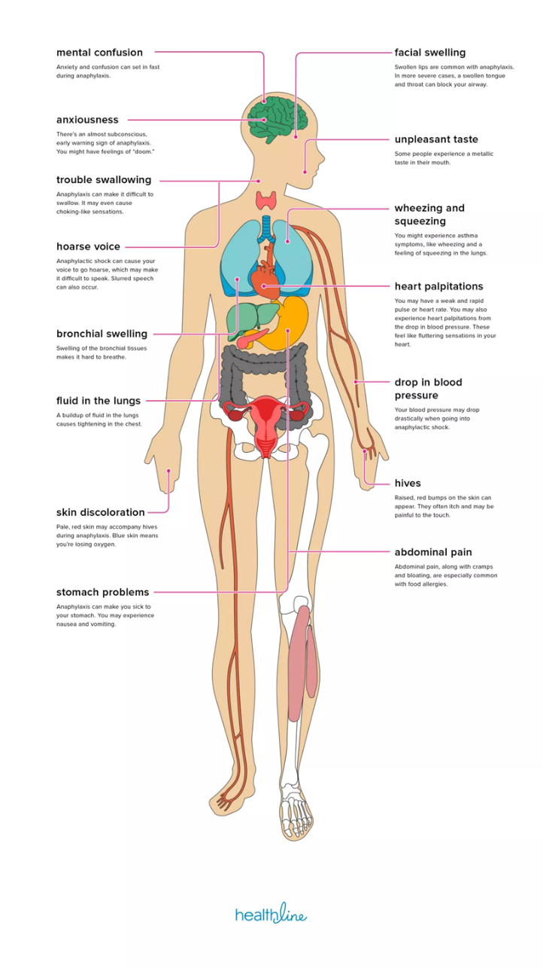
Although skin changes can be worrying or distressing for service users and those treating them, skin changes without life-threatening airway, breathing or circulation problems do not signify an anaphylactic reaction. Staff who have service users in their care who are known to have anaphylaxis reactions to known triggers must be trained and deemed competent in recognition and treatment of anaphylaxis, and if escorting service users away from the service then treatment must always be taken with them together with a means of communication in case the emergency services need to be contacted.

What is the treatment for a severe reaction?
Pre-loaded auto-injectors containing adrenaline are prescribed for people believed to be at risk of anaphylaxis. (EpiPen). Because severe allergic reactions can occur rapidly, the prescribed auto-injector must always be readily available as prescribed. Only staff trained in the use of an EpiPen are able to administer this procedure.

An ambulance must be called immediately following an injection of adrenaline, even if there is immediate improvement. The emergency service operator must be told the person is suffering from anaphylaxis and needs to be attended by paramedics.

If the person’s condition deteriorates after making the initial 999 call, a second call to the emergency services should be made to ensure an ambulance has been dispatched.

EpiPen:
To use the EpiPen, you have to first remove its safety cap. When you hold the EpiPen, wrap your thumb around the front or around the sides of the EpiPen. This is a crucial step. Remember that it has a needle that is loaded with spring.
Now, place it against the leg of the service user, over the clothes as it will go past the clothing, but where the person is wearing jeans make sure it is not pressed against the seam of the denim. When you press it, you will hear a clicking sound. The clicking sound is an indication that the needle is already activated and they can now be injected. You should hold it in for at least 10 to 15 seconds prior to removing, then give the area injected a slow rub. After that, use the needle guard located at the other end of the EpiPen. This needle guard covers the needle after the patient has been given an injection. It makes the EpiPen safe after injection. Make sure you rub the area injected by the EpiPen to help the skin absorb the adrenalin. Label the pen with the time you administered it.

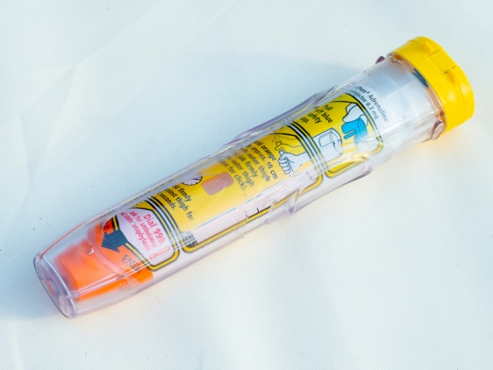
Always remember to check the expiry date of the EpiPen and replace once used as this is a single dose. It is normal practice for the service user to be prescribed 2 pens and to always take them with them when they go out. If in the service, then staff must be aware of where these pens are to be located at all times and only staff trained in the use of an EpiPen can administer this.

All pictures are for example only and may appear different when prescribed.

5. Equality Impact Assessment

Equality Impact Assessment Checklist |  | Yes/No? | Comments
1. | Does the procedural document affect one group less or more favourably than another on the basis of:
 | - Race? | No
 | - Ethnic origins (including gypsies and travellers)? | No
 | - Nationality? | No
 | - Gender? | No
 | - Culture? | No
 | - Religion or belief? | No
 | - Sexual orientation, including lesbian, gay and bisexual people? | No
 | - Age? | No
2. | Is there any evidence that some groups are affected differently? | No
3. | If you have identified potential discrimination, are there any exceptions valid, legal and/or justifiable? | N/A
4. | Is the impact of the procedural document likely to be negative? | No
5. | If so, can the impact be avoided? | N/A
6. | What alternatives are there to achieving the procedural document without the impact? | N/A
7. | Can we reduce the impact by taking different action? | N/A

If you have identified a potential discriminatory impact of this procedural document or need advice, please document the action required to avoid/reduce this impact.

