Taking a Temperature
This document is uncontrolled when downloaded or printed.

Copyright © Care4Quality Ltd All rights reserved.

Reference Number | REGCP22
Version | 1
Author | D Martin
Owned by:
Date ratified:
Ratified by:
(Signed)
Issue Date
Review Date
(Signed)
Target Audience | Registered Managers, Registered Nurses, Care Team

1 | Purpose & Application
2 | Responsibilities
3 | Legislation & Regulation
4 | Taking a temperature, oral, axilla and non-touch
5 | Equality Impact Assessment
Contents
- Purpose & Application
This policy has been developed to provide guidance and information about how to take a temperature.
Body Temperature
Hypothermia/Hyperthermia
Types of Thermometer and how to use
The policy will apply to:
- Permanent employees
- Temporary employees
- Agency workers
It will be the responsibility of managers to take any necessary action if this policy is not adhered to, taking into account the relevant regulatory responsibility.
- Responsibilities

The Nominated Individual: is accountable for the implementation of this policy in its entirety. They are a key contact for the service.
The Registered Manager & any Trained Nurses are responsible for the implementation of this policy.
Any Care Staff: that have had a competency assessment in recording the body temperature.

- Legislation and Regulation

Health and Social Care Act 2008 (Regulated Activities) Regulations 2014: Regulation 12

The intention of this regulation is to prevent people from receiving unsafe care and treatment and prevent avoidable harm or risk of harm. Providers must assess the risks to people's health and safety during any care or treatment and make sure that staff have the qualifications, competence, skills and experience to keep people safe.

Providers must make sure that the premises and any equipment used is safe and where applicable, available in sufficient quantities.
Providers must prevent and control the spread of infection. Where the responsibility for care and treatment is shared, care planning must be timely to maintain people's health, safety and welfare.

CQC understands that there may be inherent risks in carrying out care and treatment, and they will not consider it to be unsafe if providers can demonstrate that they have taken all reasonable steps to ensure the health and safety of people using their services and to manage risks that may arise during care and treatment.

CQC can prosecute for a breach of this regulation or a breach of part of the regulation if a failure to meet the regulation results in avoidable harm to a person using the service or if a person using the service is exposed to significant risk of harm. They do not have to serve a Warning Notice before prosecution.

- Body Temperature

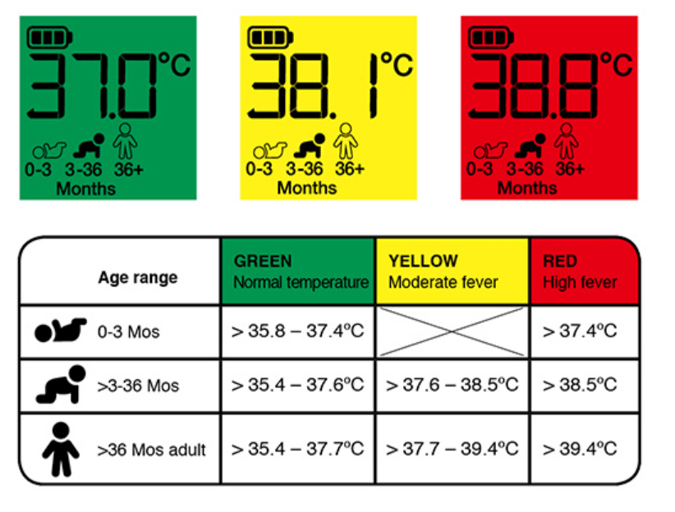

The normal body temperature for an adult is around 98.6°F (37°C), but every person’s baseline body temperature is slightly different, and may consistently be a little higher or lower.
Body temperature readings vary depending on where on the body a person takes the measurements. Rectal readings are higher than oral readings, while armpit readings tend to be lower, and the body’s ability to regulate temperature changes as you get older.
In general, older people have more difficulty conserving heat. They’re also more likely to have lower body temperatures.

For all new admissions to the service it is recommenced as good practice to record temperature, pulse, respiration rate, blood pressure and weight to give a baseline record against which all other reading may be based.
Consent must be obtained from each person before a temperature is recorded and if the person is deemed no to have capacity then MCA / BI must be in place.

Among adults, the average body temperature ranges from 97°F (36.1°C) to 99°F (37.2°C).
In older adults, the average body temperature is lower than 98.6°F (37°C).
It is important to remember that normal body temperature varies from person to person. For some, body temperature might be up to 1°F (0.6°C) higher or lower than the guidelines above. (These are examples). An area of the brain called the hypothalamus regulates body temperature. If body temperature rises above or dips below the 37°F mark, the hypothalamus kicks in to regulate the temperature. If the body is too cold, the hypothalamus sends signals to make the body shiver, which warms the body up. If the body is too hot, it sends messages to begin sweating, which lets heat leave the body.

Hyperthermia (raised temperature) can be accompanied by other signs and symptoms, including: sweating, chills, shivering, or shaking, hot or flushed skin, headache and body aches, fatigue and weakness, loss of appetite, increased heart rate and dehydration.

Hypothermia is a serious condition that occurs when the body loses too much heat. For adults, a body temperature that dips below 95°F (35°C) is a sign of hypothermia.
Signs and symptoms of hypothermia include shivering, slow, shallow breath, slurred or mumbled speech, a weak pulse, poor coordination or clumsiness, low energy or sleepiness, confusion or memory loss and loss of consciousness.

Types of thermometers

Digital Thermometer

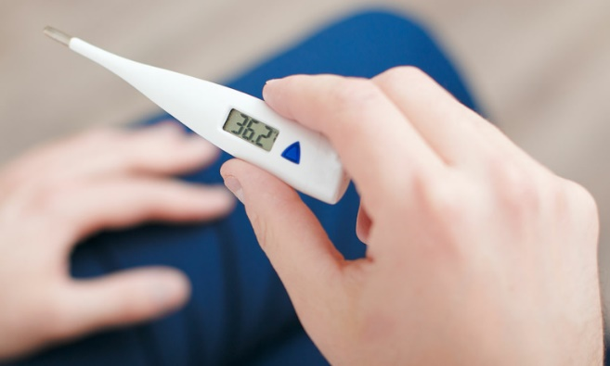
These are common types of thermometer and they should produce accurate readings when used correctly. This thermometer will record the body temperature if placed under the armpit, but a more accurate reading will be obtained from the mouth, where it should sit under the tongue but this can prove uncomfortable for some to sit under the tongue for several minutes. It is important to make sure that the person has not had a hot or cold drink or food for 30 minutes before taking the temperature, or having just come in from outside or done exercise, which can be quite restrictive and this may cause an inaccurate reading.

To use a digital thermometer:
Clean the tip with cold water and soap, then rinse it.
Turn the thermometer on.
Put the tip under the tongue, towards the back of the mouth.
Ask the person to close their lips around the thermometer.
Wait until it beeps or flashes.
Check the temperature on the display.
You can also use a digital thermometer in the armpit. Make sure the arm is tight against the body until the thermometer beeps or flashes.

Ear Thermometer
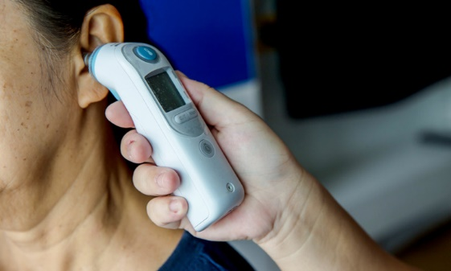
Ear thermometers are quick and easy to use, taking just a few seconds to get a reading using infrared technology to measure the temperature inside the ear. An inaccurate reading may occur if the device isn’t positioned correctly in the ear or if there’s a buildup of earwax. If not using disposable probe covers it is important to remember the need to clean the ear probe between uses.

It is important to follow the manufacturers instructions that come with the thermometer as different brands work in slightly different ways. You usually need to gently pull the ear up and back before putting the thermometer in the ear. This helps in getting a more accurate temperature.

Non-Contact Thermometers

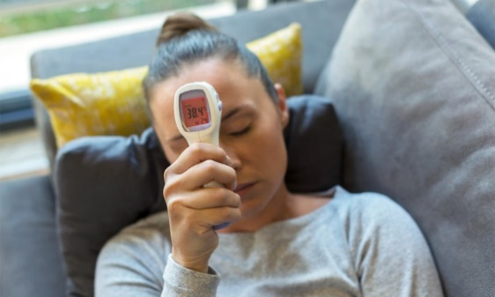
As the name suggests, with no-contact thermometers you don’t need to press the device against the skin or place it in the mouth. These thermometers use infrared technology to detect heat coming from the surface of the skin. Non-contact thermometers are a non-invasive way to check a temperature and are particularly useful in situations where the person could be caused anxiety using other forms of thermometer.

Rectal Thermometer

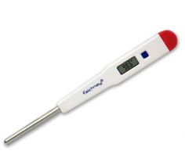
Rectal thermometers are normally only used for babies and children and may be considered an invasive procedure in some instances. If using always look to check if the thermometer is rectal or oral before taking a temperature. There is no difference in the way they take temperatures, but the shape of the tip is different. A rectal thermometer has a round tip while an oral thermometer has a
longer, thin tip. A rectal thermometer should never be used to take an oral temperature and an oral thermometer should never be used to take a rectal temperature. Both thermometers can be used to take an axillary (under the armpit) temperature.

It is not recommenced to use a glass thermometer or a forehead strip as glass thermometers can be dangerous and forehead strips are not accurate.

** Ensure that you record readings accurately and legibly in the appropriate section of the care documentation. **

Service Specific Information
Where are the thermometers kept?
Who is responsible for maintaining the stock of ear probe covers?
Have staff read and do they understand how to take someone’s temperature and when they need to summon medical assistance?

5. Equality Impact Assessment

Equality Impact Assessment Checklist |  | Yes/No? | Comments
1. | Does the procedural document affect one group less or more favourably than another on the basis of:
 | - Race? | No
 | - Ethnic origins (including gypsies and travellers)? | No
 | - Nationality? | No
 | - Gender? | No
 | - Culture? | No
 | - Religion or belief? | No
 | - Sexual orientation, including lesbian, gay and bisexual people? | No
 | - Age? | No
2. | Is there any evidence that some groups are affected differently? | No
3. | If you have identified potential discrimination, are there any exceptions valid, legal and/or justifiable? | N/A
4. | Is the impact of the procedural document likely to be negative? | No
5. | If so, can the impact be avoided? | N/A
6. | What alternatives are there to achieving the procedural document without the impact? | N/A
7. | Can we reduce the impact by taking different action? | N/A

If you have identified a potential discriminatory impact of this procedural document or need advice, please document the action required to avoid/reduce this impact.

