Oxygen Administration Use
This document is uncontrolled when downloaded or printed.

Copyright © Care4Quality Ltd. All rights reserved.

Reference Number | REGCP14
Version | 1
Author | D Martin
Owned by:
Date ratified:
Ratified by:
(Signed)
Issue Date
Review Date
(Signed)
Target Audience | Registered Managers, Registered Nurses, Care Team

1 | Purpose & Application
2 | Responsibilities
3 | Legislation & Regulation
4 | Use of Oxygen
5 | Equality Impact Assessment
Contents
- Purpose & Application
This policy has been developed to provide guidance and information about how to support people who are receiving oxygen.
Use of Oxygen
Face masks and nasal cannula
Documentation and administration
Safety (incl. Storage and emergency stock use)
Staff training
The policy will apply to:
- Permanent employees
- Temporary employees
- Agency workers
It will be the responsibility of managers to take any necessary action if this policy is not adhered to, taking into account the relevant regulatory responsibility.
- Responsibilities

The nominated individual is accountable for the implementation of this policy in its entirety. They are a key contact for the service.
The registered manager and any trained nurses are responsible for the implementation of this policy.
Any care staff that have had a competency assessment in the use and administration of oxygen either by cylinder or concentrator.

- Legislation and Regulation

Health and Social Care Act 2008 (Regulated Activities) Regulations 2014: Regulation 12

The intention of this regulation is to prevent people from receiving unsafe care and treatment and prevent avoidable harm or risk of harm. Providers must assess the risks to people's health and safety during any care or treatment and make sure that staff have the qualifications, competence, skills and experience to keep people safe.

Providers must make sure that the premises and any equipment used is safe and where applicable, available in sufficient quantities.

Providers must prevent and control the spread of infection. Where the responsibility for care and treatment is shared, care planning must be timely to maintain people's health, safety and welfare.

CQC understands that there may be inherent risks in carrying out care and treatment, and they will not consider it to be unsafe if providers can demonstrate that they have taken all reasonable steps to ensure the health and safety of people using their services and to manage risks that may arise during care and treatment.

CQC can prosecute for a breach of this regulation or a breach of part of the regulation if a failure to meet the regulation results in avoidable harm to a person using the service or if a person using the service is exposed to significant risk of harm. They do not have to serve a Warning Notice before prosecution.

- Use of Oxygen

All oxygen must be prescribed by a registered health care professional and a request sent to the supplier providing oxygen in the area. The company will then supply all the equipment needed.
Oxygen is normally provided through one, or a combination, of either an oxygen concentrator which is either portable or static or an oxygen cylinder large or small that contains oxygen as a gas.

Nasal cannula and face masks
Oxygen therapy can be administered through either nasal cannula or a face mask.
An oxygen mask is held over the nose and mouth by elastic straps around the head and need to be adjusted to ensure a close fit, and the oxygen is delivered through tubing that is connected to the mask at a rate prescribed by the GP.

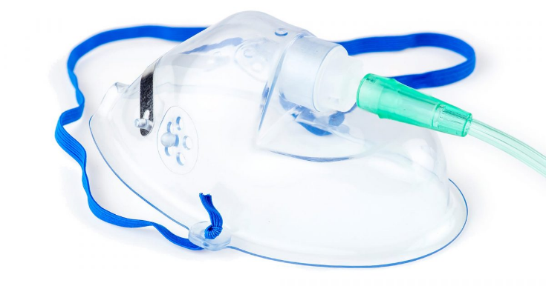

Nasal cannula brings oxygen from the concentrator or cylinder to the nose through flexible tubing. Care should be taken to ensure that tubes and masks are kept clean and in good condition and that the tube is not crushed or kinked. Tubing and masks/nasal cannula should be replaced on a regular basis as required and a spare supply of same must always be available.

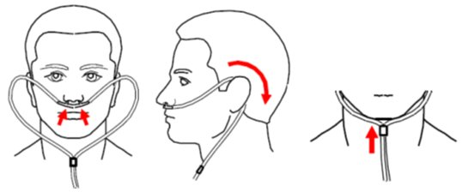

Documentation and Administration
Documentation must be in place covering the ordering, receipt, storage, administration and removal of the oxygen cylinders and concentrators.
- All staff need to be aware of informing the emergency services of the location of oxygen if they are required to attend in the event of a fire or fire alarm including a notice on the door of the room oxygen is used in, stored in and also a notice to be placed on the fire panel indicating where oxygen is in the building.
- Documentation must be in place covering the administration details for the oxygen. This must include the flow rate and length of time the oxygen should be used for and the prescriber’s details. The flow rate and duration of the therapy must not be altered unless advised to do so by the prescriber. All changes must be documented.
- Individual residents’ care plans and medicine administration records must detail: the reason for the oxygen use, who prescribed it, the prescribed flow rate, duration and device used and the oxygen monitoring plan.
- The oxygen care plan must also include details of target oxygen saturations, escalation plan in the case of clinical deterioration, details of the risk assessment, date the risk assessment was done.
- Care plans should include the risks associated with: smoking (including risks with electronic cigarettes), heat sources (such as heaters in bedrooms), flammable liquids (such as aerosols), petroleum based products and other emollient preparations and using electronic devices (such as laptops).
- Oxygen equipment must be checked at each administration to ensure the correct flow rate is selected.
- Where fitted, the inlet filter in an oxygen concentrator should be cleaned once a week and evidence of this needs to be in place so this can be monitored.
- Do not share cannula, tubing or masks, there must be individual equipment in place.
- A documented robust risk assessment must be in place for both the use and storage of the oxygen.
- Safety advice provided by the supplier must be available to all staff administering oxygen and the advice must be followed.
- If the person is self-administering the oxygen then a documented robust risk assessment must be in place and regularly reviewed to assess their ability to do so correctly and safely.
- Oxygen and associated equipment (for example, masks/nasal cannula and tubing) must only be used for the person for whom it was supplied.
- The administration of oxygen is a specialised technique and only staff who have been appropriately trained can administer oxygen. Training should be documented. (See section below on staff training)
- Oxygen cylinders have an expiry date, and this must be checked on a regular basis to ensure that out of date oxygen is not used.
- Oil based products must not be allowed to come into contact with the oxygen. (See safety below)
- Equipment must never be lubricated with oil-based products. Only products which are provided or advised by the supplier should be used on the oxygen equipment. Hands should be washed before handling the equipment to ensure no grease is present on the hands.
- If the person has dry skin, especially around the nose and face areas where the mask or nasal cannula sits, a water-based moisturiser should be used.
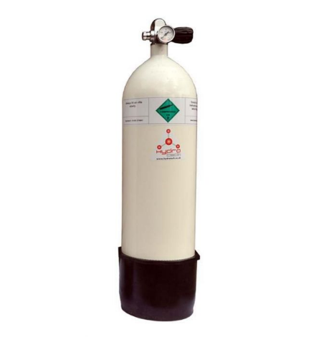
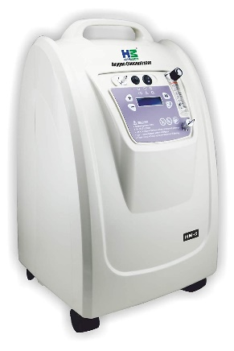

CQC guidance states “You must record the following information in the person’s oxygen care plan and medicines administration record: the normal oxygen saturations for the person, both on air and on their usual oxygen therapy - this should be monitored in line with the care plan,
the escalation plan for any person on home oxygen under your care, who to contact if they are unwell and what to do and personal emergency evacuation plan (PEEP)”.

Safety
- Oxygen can be a dangerous fire hazard. Take adequate precautions while oxygen is being used.
- Oxygen should not be prescribed to a current smoker. If there is concern about oxygen and smoking, the prescriber of the oxygen must be notified immediately.
- People should not smoke where oxygen is being used.
- Keep oxygen at least two metres away from flames or heat sources.
- Do not use flammable liquids, such as paint thinners or aerosols, near oxygen.
- Do not use petroleum-based products (such as Vaseline® or Vicks®) or other emollients near oxygen.
- Make sure that fire alarms and smoke detectors are working.
- Include oxygen use in the fire risk assessment

Storage
- Store oxygen cylinders securely to prevent the cylinder from falling
- Away from areas that would block escape routes or fire exits
- In well ventilated areas
- Away from heat and light sources
- In an area that is not used to store any other flammable materials
- Away from combustible material (such as paper, cardboard, curtains)
- Not covered by items of clothing.
- Store oxygen concentrators upright. Plug them directly into the mains. Do not use an extension lead.
- Any oxygen cylinders/concentrators which are no longer required should be returned to the supplier. Cylinders which are empty or passed their expiry date should also be returned to the supplier.
- Staff should not attempt to repair oxygen cylinders or concentrators. Any problems should be reported promptly to the supplier.

Holding stock for emergency use
If supplies of oxygen for emergency use are stored, there needs to be appropriate equipment and storage space that is safe and fit for purpose and a written guidelines outlining how and when emergency oxygen is to be used on an individual basis.
Staff must be regularly trained in emergency oxygen use and in the details of the policy.

Staff training
All staff involved in the use of oxygen, must have appropriate and ongoing training in safe oxygen storage and use. Oxygen saturations must be monitored according to an agreed care plan for each person on oxygen. The oxygen care plan should include the normal oxygen saturations for the person (both on air and on their usual oxygen therapy). This should be monitored daily as part of their regular care or as instructed by health professionals. Staff must be able to monitor and respond to a resident’s oxygen saturations in line with their care plan.

Photographs used in this policy may differ from ones in use by different organisations and is included for example only.

Service Specific Information
Are breathing care plans in place where necessary for people requiring Oxygen therapy? Are base observation levels included in the care plan and is a rescue plan in place?
Who is responsible for overseeing Oxygen management?
Does the fire risk assessment include the correct details around Oxygen use in the service?

5. Equality Impact Assessment

Equality impact assessment checklist |  | Yes/No? | Comments
1. | Does the procedural document affect one group less or more favourably than  another on the basis of: | No
 | - Race? | No
 | - Ethnic origins (including gypsies and travellers)? | No
 | - Nationality? | No
 | - Gender? | No
 | - Culture? | No
 | - Religion or belief? | No
 | - Sexual orientation including lesbian, gay and bisexual people? | No
 | - Age? | No
2. | Is there any evidence that some groups  are affected differently? | No
3. | If you have identified potential discrimination, are there any exceptions  valid, legal and/or justifiable? | N/A
4. | Is the impact of the procedural document  likely to be negative? | No
5. | If so, can the impact be avoided? | N/A
6. | What alternatives are there to achieving the procedural document without the  impact? | N/A
7. | Can we reduce the impact by taking  different action? | N/A

If you have identified a potential discriminatory impact of this procedural document or need advice, please document the action required to avoid/reduce this impact.

