Pressure Care Covering Assessment, Treatment of Stage I, II, III & IV, DTI & Unstageable, Aseptic Techniques
This document is uncontrolled when downloaded or printed.

Copyright © Care4Quality Ltd. All rights reserved.

Reference Number | REGCP10
Version | 1
Author | D. Martin
Owned by:
Date ratified:
Ratified by:
(Signed)
Issue Date
Review Date
(Signed)
Target Audience | Registered Managers, Registered Nurses, Care Team

Contents
1 | Purpose and Application
2 | Responsibilities
3 | Legislation and Regulation
4 | Pressure Area Care and Prevention of Pressure Sores: Policy & Procedure
5 | Equality Impact Assessment

- Purpose & Application

This policy has been developed to provide guidance and information about pressure care covering assessment, treatment of Stage I, II, III & IV, DTI and unstageable and aseptic techniques:

What are pressure areas/ulcers?
Grading of pressure ulcers
Assessment and evaluation
Relief of pressure over the body
Aseptic wound care
The policy will apply to:
- Permanent employees
- Temporary employees
- Agency workers
It will be the responsibility of managers to take any necessary action if this policy is not adhered to, taking into account the relevant regulatory responsibility.
- Responsibilities

The nominated individual is accountable for the implementation of this policy in its entirety. They are a key contact for the service.

The registered manager and any trained nurses are responsible for the implementation of this policy.

Any care staff that have had a competency assessment in caring for people prone to and who have pressure ulcers including changing of dressings.

- Legislation and Regulation

Health and Social Care Act 2008 (Regulated Activities) Regulations 2014: Regulation 12

The intention of this regulation is to prevent people from receiving unsafe care and treatment and prevent avoidable harm or risk of harm. Providers must assess the risks to people's health and safety during any care or treatment and make sure that staff have the qualifications, competence, skills and experience to keep people safe.

Providers must make sure that the premises and any equipment used is safe and, where applicable, available in sufficient quantities. Medicines including topical creams and dressings must be supplied in sufficient quantities, managed safely, and administered appropriately to make sure people are safe.

Providers must prevent and control the spread of infection. Where the responsibility for care and treatment is shared, care planning must be timely to maintain people's health, safety, and welfare.

CQC understands that there may be inherent risks in carrying out care and treatment, and we will not consider it to be unsafe if providers can demonstrate that they have taken all reasonable steps to ensure the health and safety of people using their services and to manage risks that may arise during care and treatment.

CQC can prosecute for a breach of this regulation or a breach of part of the regulation if a failure to meet the regulation results in avoidable harm to a person using the service or if a person using the service is exposed to significant risk of harm. They do not have to serve a Warning Notice before prosecution.

- Pressure Area Care and Prevention of Pressure Sores: Policy & Procedure

Pressure ulcers, sometimes known as “bed sores” or “pressure sores” are an injury that breaks down the skin and underlying tissue. They are caused when an area of skin is placed under pressure. They can range in severity from patches of discoloured skin to open wounds that expose underlying bone or muscles. All staff at all levels must work closely with health professionals and residents to prevent the development of pressure sores.

Pressure sores are graded according to their severity and have been classified as follows:

Grade One: a grade one pressure ulcer is the most superficial type of ulcer. The affected area of skin appears discoloured – it is red in white people, and purple or blue in people with darker-coloured skin. Grade one pressure ulcers do not turn white when pressure is placed on them. The skin remains intact, but it may hurt or itch. It may also feel either warm and spongy, or hard.

Grade Two: in grade two pressure ulcers, some of the outer surface of the skin (the epidermis) or the deeper layer of skin (the dermis) is damaged, leading to skin loss. The ulcer looks like an open wound or a blister.

Grade Three: in grade three pressure ulcers, skin loss occurs throughout the entire thickness of the skin. The underlying tissue is also damaged, although the underlying muscle and bone are not. The ulcer appears as a deep, cavity-like wound.

Grade Four: a grade four pressure ulcer is the most severe type of pressure ulcer. The skin is severely damaged, and the surrounding tissue begins to die (tissue necrosis). The underlying muscles or bone may also be damaged. People with grade four pressure ulcers have a high risk of developing a life-threatening infection.

Ungradable Pressure Sore: full thickness skin/tissue loss where the depth of the ulcer is completely obscured by slough and/or necrotic tissue. Until enough slough and necrotic tissue is removed to expose the base of the wound, the true depth cannot be determined.

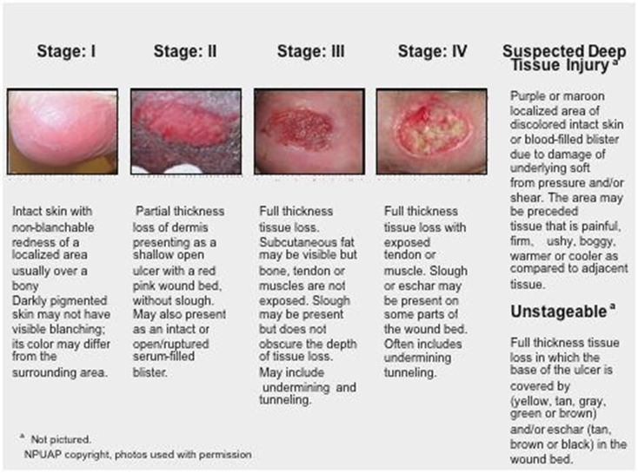

Pressure Sore Risk Assessment (PSRA)
Many residents will be “at risk” from developing pressure sores, especially those unable to get out of bed, those with little mobilisation or those in wheelchairs. Therefore, it is inevitable that the use of a recognised assessment tool is incorporated into the initial and subsequent care planning process. If the resident has a pressure ulcer it is important to record its size and position, a photograph to be taken if appropriate and with consent of the person involved (MCA /BI to be done for people who are deemed not to have capacity for “sharing of information”) and outside health professionals involved who may include the GP/DN/TVN for appropriate prescription of dressings required.

The initial calculation and score should be ascertained, if possible, when the pressure sore has been noted. A common assessment tool in current use is Waterlow, but this is one of many used. The assessment tool is not a substitute for sound clinical judgement; it is an adjunct and a means of helping to identify those people at risk.

Predisposing factors that may be contributory to pressure sore formation may include but not limited to:

- Undue or prolonged pressure,
- Friction,
- Shearing forces, e.g. ill-fitting shoes or poor moving and handling procedures,
- Incontinence,
- Poor nourishment or dehydration,
- Chronic illness, e.g. vascular disease and diabetes,
- Rubbing together of skin surfaces,
- Immobility/reduced mobility,
- Impaired circulation,
- Age,
- Decreased consciousness/mental awareness,
- Reduced sensation, e.g. multiple sclerosis, and
- Medications, e.g. steroids sedatives and pain.

Assessment
Skin inspection and documentation using a recognised scoring system is vital. Record the presence of or the potential for a pressure sore in the care plan and report to the manager/ District Nurse/Tissue Viability Nurse as appropriate.
The Registered Nurse/District Nurse/Tissue Viability Nurse will advise how the following will be carried out in relation to individual residents who may need extra assistance with nutrition.

Nutrition
Nutrition is an essential factor in the prevention and treatment of pressure sores. The following aspects will need to be taken into consideration:

- A good fluid intake, unless otherwise indicated.
- Sufficient calories to meet energy requirements ― increased when wounds are present.
- Sufficient protein intake: additional vitamins and extra fibre can be useful.
- Food supplements/fortification of food should be used for residents whose appetite is poor and a consultation with the GP regarding nutritional supplements may be needed.

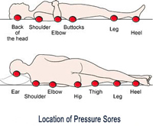
Movement
Repositioning may be required more frequently, depending on the condition of the resident. This applies to all residents who spend much of their time in bed or in their chair unable to move themselves. All staff must be trained in moving and handling, be deemed competent to use moving and handling equipment and the care plan must state what equipment is to be used such as hoist, slide sheet, use of pressure relieving equipment to name a few. This needs to completed on an individual basis.

Care of the Skin
Skin integrity should be maintained where possible. Too frequent washing will remove the skin’s natural oils, which forms a barrier to infection. A mild soap can used to minimise the change of pH in the skin. The skin must be dried by patting. Only specific, prescribed emollients and topical creams may be used. These should only be used where necessary, and sparingly, as they can interfere with the effectiveness of incontinence products.
All creams and emollients must be documented on the resident’s MAR, and if it is paraffin-based, the topical treatment must have a flammable risk assessment together with staff guidance in the care plan.

Continence Planning
It is essential that thorough assessment is undertaken by qualified professionals for any resident who is incontinent; this is to ensure that a comprehensive programme is formulated for keeping pressure ulcer formation to a minimum and maintaining skin integrity. There may be a need for the person to be catheterised to maintain skin integrity, but this needs to be discussed with the GP.

Pressure-Relieving Equipment
There will be a need for pressure relieving equipment for anyone who has a pressure sore. These can include pressure relieving mattresses, either overlay or full replacement, pressure relieving cushions for wheelchairs or armchairs and there may be a need for further pressure relief for feet and arms. This will be decided at the time of assessments and must be ongoing. Referral to outside authorities will be made by the registered nurse or GP as appropriate.
Pressure relief aids should provide a surface that conforms to body weight and reduces frictional sores. All pressure relieving mattresses must be set according to the persons weight if not self-adjusting and this needs to be documented.

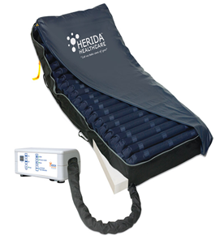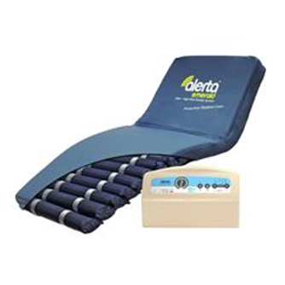
Evaluation
This must be according to criteria identified within the care plan and incorporating the same assessment tool used in the initial assessment.

The aims of preventative procedures are as follows:

- To identify those residents who are at risk from developing pressure sores.
- To work to promote prevention or in treating pressure sores.
- To compile individualised care/support plans and risk assessments, incorporating the rationale to prevent the formation of pressure sores.
- To encourage the residents’ co-operation in the objectives of prevention.
- To encourage healing where a pressure sore is established.
- To monitor the incidence of pressure sores.
- To continually reassess/review residents deemed “at risk”.

Treatments for Pressure Ulcers (Sores)
This includes regularly changing the person’s position, using special mattresses to reduce or relieve pressure, and dressings to help heal the ulcer. Surgery may sometimes be needed. Moving and regularly changing the person’s position helps to relieve the pressure on ulcers that have already developed. It also helps prevent pressure ulcers forming. This re-positioning regime needs to be clear in the plan of care, well evidenced and all staff must be aware. Timings for repositioning will be made on an individual basis according to the degree of pressure on areas of the body.

Dressings
Specially designed dressings can be used to protect pressure ulcers and speed up the healing process and these can include:

- Alginate dressings are made from seaweed and contain sodium and calcium, which are known to speed up the healing process.
- Hydrocolloid dressings contain a gel that encourages the growth of new skin cells in the ulcer, while keeping the surrounding healthy skin dry
- Other dressing types, such as foams, films, hydrofibres/gelling fibres, gels and antimicrobial (antibiotic) dressings may also be used.

All dressings will be prescribed from the GP or other health professionals involved in the care. Gauze dressings are not recommended for either the prevention or treatment of pressure ulcers.

Creams and Ointments
Topical antiseptic or antimicrobial (antibiotic) creams and ointments are not usually recommended for treating pressure ulcers, but barrier creams may be needed to protect skin that has been damaged or irritated by incontinence.

Antibiotics
Antibiotics may be prescribed to treat an infected ulcer or if there is a serious infection, such as blood poisoning (sepsis), bacterial infection of tissues under the skin (cellulitis), infection of the bone (osteomyelitis).

Diet and Nutrition
Eating a healthy, balanced diet that contains enough protein and a good variety of vitamins and minerals can speed up the healing process. It is also important to drink plenty of fluids to avoid dehydration, because being dehydrated can slow down the healing process.

Removing Damaged Tissue (Debridement)
It may sometimes be necessary to remove dead tissue from the pressure ulcer to help it heal. This is known as debridement. If there is a small amount of dead tissue, it may be removed using specially designed dressings prescribed, but large areas of dead tissue may need surgical debridement. This may involve cleaning the wound and closing it by bringing the edges of the ulcer together, cleaning the wound and using tissue from healthy skin nearby to close the ulcer. It is important to remember that pressure ulcer surgery can be challenging, especially because most people who have the procedure are already in a poor state of health. Risks after surgery include may include the implanted skin tissue dying, blood poisoning (sepsis), infection of the bone (osteomyelitis) and abscess formation.

Aseptic Technique
When applying or changing dressings, an aseptic technique is used to avoid introducing infections into a wound. Even if a wound is already infected, an aseptic technique should be used as it is important that no further infection is introduced.

Preparation
Prior to changing the dressing, there needs to be a clear available workspace, such as a stainless-steel trolley. The space must be big enough for the dressing pack to be opened on, for a sterile dressing/procedure pack, access to a hand washing sink, non-sterile gloves to remove old dressings, an apron, appropriate dressings as prescribed and solution for cleaning the wound, if needed.

- Introduce and give full explanation to the person and gain consent if possible (MCA/BI to be done for people who are deemed not to have capacity for “sharing of information”).
- Position the person comfortably and make sure the surrounding area is clean and tidy before commencing.
- Check the care notes/dressing regime for any changes and to make sure the dressing is due to be changed.
- Wash your hands and put on an apron.
- Clean the area before use and place the sterile dressing/procedure pack on the top of the trolley.
- Open the sterile dressing pack on top of the trolley. Open the sterile field using the corners of the paper and open any other sterile items needed onto the sterile field without touching them.
- Remove the old dressing and dispose of in a separate dirty clinical waste bag.

Complete a Wound Assessment
This includes a visual check and comparing and evaluating the smell, amount of blood or ooze (excretions) and their colour, and the size of the wound.
If the site has not improved as expected, then the GP must be informed so an evaluation can be made, and a review of the dressing used and further treatment commenced as required.

Cleaning and Dressing the Wound
Make sure that the correct dressing type and materials are selected to provide full and appropriate coverage of the type, size and location of the wound as per the care plan or agreed dressing regime. Dress the wound as per instructions. Once the dressing is completed, place all contaminated material in a clinical waste bag and dispose of it as per policy and procedure. Record (document) the wound assessment, the dressing change and the care that has been given.

Regulation 20: Duty of Candour
When a pressure sore of Grade 3 or above develops after the person has started to use the service, a notification must be sent to CQC as required under the above Regulation. Local authorities have their own threshold for notification and these need to be consulted in line with legislation and local authority guidelines.

Photographs used in this policy may differ from ones in use in different organisations.

Service Specific Information
Who is responsible for checking that all pressure-relieving mattresses are set correctly?
Are there robust mechanisms in place to ensure that checks are carried out regularly and setting clearly identified in the care plans?
Who is responsible for updating the care plan and risk assessment, if required?
Who is responsible for ensuring that wound management charts are in place and being completed and reviewed on a regular basis?
Is there sufficient evidence that, when appropriate, there are mechanisms in place for escalation of concerns around wounds?
Grade 3 (and above) pressure sores need to be notified to CQC via notification form and safeguarding (check local thresholds).

- Equality Impact Assessment

Equality Impact Assessment Checklist |  | Yes/No? | Comments
1. | Does the procedural document affect one group less or more favourably than another on the basis of:
 | - Race? | No
 | - Ethnic origins (including gypsies and travelers)? | No
 | - Nationality? | No
 | - Gender? | No
 | - Culture? | Yes | There is a possibility that, due to cultural and religious choices, the ingredients of some dressings may be opposing to some beliefs. Staff need to be aware of any cultural preferences and choices of the service user.
 | - Religion or belief? | Yes
 | - Sexual orientation, including lesbian, gay and bisexual people? | No
 | - Age? | No
2. | Is there any evidence that some groups are affected differently? | No
3. | If you have identified potential discrimination, are there any exceptions valid, legal and/or justifiable? | N/A
4. | Is the impact of the procedural document likely to be negative? | No
5. | If so, can the impact be avoided? | N/A
6. | What alternatives are there to achieving the procedural document without the impact? | N/A
7. | Can we reduce the impact by taking different action? | N/A

If you have identified a potential discriminatory impact of this procedural document or need advice, please document the action required to avoid/reduce this impact.

