Compression Hosiery
This document is uncontrolled when downloaded or printed

Copyright © Care4Quality Ltd. All rights reserved.

Reference Number | REGCP01
Version | 1
Author | H. Fuller
Owned by:
Date ratified:
Ratified by:
(Signed)
Issue Date
Review Date
(Signed)
Target Audience | Registered Managers, Registered Nurses, Care Team

Contents
1 | Purpose and Application
2 | Responsibilities
3 | Legislation and Regulation
4 | Compression Hosiery: Policy & Procedure
5 | Equality Impact Assessment

- Purpose & Application

This policy has been developed to provide guidance and information around the use of compression hosiery within our care service.

The aim of the policy is to put in place proper procedures to ensure that the compression hosiery is suitable and safe to use and is applied correctly from a properly trained and competent staff member.

The policy will apply to:

- Permanent employees
- Temporary employees
- Agency workers

It will be the responsibility of the managers to take any necessary action in the event that this policy is not adhered to, taking into account the relevant regulatory responsibility.

- Responsibilities

The nominated individual is accountable for the implementation of this policy in its entirety. They are a key contact for the service.

The registered manager and any trained nurses are responsible for the implementation of this policy

Any care staff that have had a competency assessment in putting on and removing compression hosiery.

- Legislation and Regulation

Health and Social Care Act 2008 (Regulated Activities) Regulations 2014: Regulation 12

The intention of this regulation is to prevent people from receiving unsafe care and treatment and prevent avoidable harm or risk of harm. Providers must assess the risks to people's health and safety during any care or treatment and make sure that staff have the qualifications, competence, skills, and experience to keep people safe.

Providers must make sure that the premises and any equipment used is safe and where applicable, available in sufficient quantities. Medicines must be supplied in sufficient quantities, managed safely, and administered appropriately to make sure people are safe.

Providers must prevent and control the spread of infection. Where the responsibility for care and treatment is shared, care planning must be timely to maintain people's health, safety, and welfare.

CQC understands that there may be inherent risks in carrying out care and treatment, and we will not consider it to be unsafe if providers can demonstrate that they have taken all reasonable steps to ensure the health and safety of people using their services and to manage risks that may arise during care and treatment.

CQC can prosecute for a breach of this regulation or a breach of part of the regulation if a failure to meet the regulation results in avoidable harm to a person using the service or if a person using the service is exposed to significant risk of harm. CQC do not have to serve a Warning Notice before prosecution.

- Compression Hosiery: Policy & Procedure

Compression stockings are useful for treating conditions associated with chronic venous insufficiency, including venous ulcers, varicose veins, venous eczema, post-thrombotic syndrome, and lipodermatosclerosis.

They provide graduated pressure from the distal to proximal portion of the leg and increase venous blood flow by improving the action of the calf-muscle pump.

They vary in degree of compression, measured at the ankle (class), length (below knee or thigh length), colour, and whether they are closed or open-toe.

Stockings prescribed in primary care follow the British standard for class of compression:

- Class 1 stockings (light compression) exert an ankle pressure of 14–17 mmHg.
- Class 2 stockings (medium compression) exert an ankle pressure of 18–24 mmHg.
- Class 3 stockings (high compression) exert an ankle pressure of 25–35 mmHg.

Hospitals may provide European standard stockings which provide a stronger degree of compression for each class.

Before prescribing, arterial insufficiency should be excluded by measuring the ankle-brachial pressure index (ABPI) using a Doppler machine.

- ABPI less than 0.8 — compression stockings are contraindicated, as severe arterial insufficiency is likely. The person should be referred for a specialist vascular assessment.
- ABPI 0.8–1.3 — compression stockings are safe to wear.
- ABPI greater than 1.3 — compression should be avoided, as high ABPI values may be due to calcified and incompressible arteries. The person should be referred for a specialist vascular assessment.

The condition of the skin should be checked; fragile skin may be damaged while putting on or removing compression stockings. Ideally, venous ulcers should be healed before using compression stockings.

The person should be assessed to ensure they can manage compression stockings; conditions such as arthritis may make it difficult for the person to put on or remove stockings. Care staff should be trained to support with putting on and removing stockings. This needs to be recorded on their staff competency records.

The degree of compression (class of stocking) used should depend on the condition being treated. It should be the highest the person can tolerate.
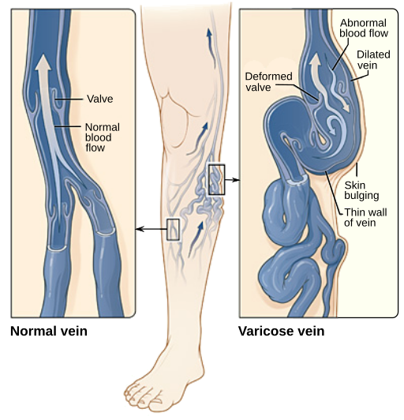
Varicose veins: Class 1 or 2 stockings, depending on the severity.

Venous eczema, lipodermatosclerosis, Atrophie blanche, healed venous leg ulcers: Class 2 stockings, Class 3 stockings if there is an inadequate response to Class 2 stockings, or Class 1 if Class 2 is not tolerated.

Superficial thrombophlebitis: Class 2 stockings; however, most people find Class 2 stockings too painful. Class 1 stockings or travel socks are practical alternatives.

Below-knee compression stockings are usually preferred. Thigh-length stockings should be considered if there are severe varicose veins above the knee or swelling which extends above the knee.

Open-toe stockings may be necessary if the person:

- Has arthritic or clawed toes, or fungal infection.
- Prefers to wear a sock over the compression stocking.
- Has a long foot size compared with their calf size.

Compression stockings should be removed at bedtime, but if this is not possible they can be worn continuously for up to a maximum of 7 days.

Compression stockings should be replaced every 3–6 months. Ideally, each time a stocking is replaced, the leg should be re-measured.

https://cks.nice.org.uk/topics/compression-stockings/#:~:text=Compression%20stockings%
20should%20be%20removed,leg%20should%20be%20re%2Dmeasured.
How Can I Encourage Compliance with Wearing Stockings?

- Ensure that the person understands the reasons for, and the benefits of, wearing compression stockings.

- Ensure that the person has been shown how to put on and take off the stocking and that they are able to do so.

- If the person is having difficulty, an application aid may be prescribed (for example, ACTi Glide®).

- Explain that the best time to put stockings on is first thing in the morning, before any leg swelling develops.

- Check that the person is happy with the colour of the stocking. Men may prefer black or other colours, rather than flesh-coloured.

- Ensure that the stocking is a correct fit; if standard sizes are not suitable, the person may need a made-to-measure stocking.

- If the person is having difficulty tolerating the level of compression, they may try a lighter compression stocking.

- If the person is having difficulty using a thigh-length stocking, consider switching to a below-knee stocking (thigh-length stockings are not usually necessary).

- Explain that the stocking should be taken off at bedtime.

- Recommend the application of an emollient while the stocking is off, to reduce skin dryness and irritation.

- Explain the importance of a regular review and replacement of stockings to ensure they continue to fit well and provide the correct level of compression.

Service Specific Information

- Equality Impact Assessment

Equality Impact Assessment Checklist |  | Yes/No? | Comments
1. | Does the procedural document affect one group less or more favourably than another on the basis of:
 | - Race? | No
 | - Ethnic origins (including gypsies and travelers)? | No
 | - Nationality? | No
 | - Gender? | No
 | - Culture? | No
 | - Religion or belief? | No
 | - Sexual orientation, including lesbian, gay and bisexual people? | No
 | - Age? | No
2. | Is there any evidence that some groups are affected differently? | Not intentionally, but due to the nature of the policy it is a possibility. | There is potential for discrimination due to the dexterous and physical nature of putting on and removing compression hosiery. Discussions and subsequent actions will need to be carried out in a non-discriminatory and supportive way to achieve best outcomes for service users.
3. | If you have identified potential discrimination, are there any exceptions valid, legal and/or justifiable? | N/A
4. | Is the impact of the procedural document likely to be negative? | No
5. | If so, can the impact be avoided? | N/A
6. | What alternatives are there to achieving the procedural document without the impact? | N/A
7. | Can we reduce the impact by taking different action? | N/A

If you have identified a potential discriminatory impact of this procedural document or need advice, please document the action required to avoid/reduce this impact.

