Diabetes Care including Blood Glucose Monitoring, Insulin Administration (covering Subcutaneous Injection), Insulin Pen Use and Insulin Pump Therapy
This document is uncontrolled when downloaded or printed

Copyright © Care4Quality Ltd. All rights reserved.

Reference Number | REGCP08
Version | 1
Author | D Martin
Owned by:
Date ratified:
Ratified by:
(Signed)
Issue Date
Review Date
(Signed)
Target Audience | Registered Managers, Registered Nurses, Care Team

1 | Purpose and Application
2 | Responsibilities
3 | Legislation and Regulation
4 | Diabetes Care: Policy & Procedure
5 | Equality Impact Assessment
Contents
- Purpose and Application
This policy has been developed to provide guidance and information about diabetes care, covering:

What is diabetes type 1 & 2?
Types of insulin
Hypo and hyperglycaemic episodes
Methods that may be used to test blood sugar (BM) levels and HbA1c test
Complications of diabetes

The policy will apply to:

- Permanent employees
- Temporary employees
- Agency workers

It will be the responsibility of the managers to take any necessary action if this policy is not adhered to, taking into account the relevant regulatory responsibility.

- Responsibilities

The nominated individual is accountable for the implementation of this policy in its entirety. They are a key contact for the service.

The registered manager and any trained nurses are responsible for the implementation of this policy.

Any care staff that have had a competency assessment in caring for and assisting people with diabetes, including use of BM meters.

- Legislation and Regulation

Health and Social Care Act 2008 (Regulated Activities) Regulations 2014: Regulation 12

The intention of this regulation is to prevent people from receiving unsafe care and treatment and prevent avoidable harm or risk of harm. Providers must assess the risks to people's health and safety during any care or treatment and make sure that staff have the qualifications, competence, skills and experience to keep people safe.

Providers must make sure that the premises and any equipment used is safe and where applicable, available in sufficient quantities. Medicines must be supplied in sufficient quantities, managed safely and administered appropriately to make sure people are safe.

Providers must prevent and control the spread of infection. Where the responsibility for care and treatment is shared, care planning must be timely to maintain people's health, safety and welfare.

CQC understands that there may be inherent risks in carrying out care and treatment, and we will not consider it to be unsafe if providers can demonstrate that they have taken all reasonable steps to ensure the health and safety of people using their services and to manage risks that may arise during care and treatment.

CQC can prosecute for a breach of this regulation or a breach of part of the regulation if a failure to meet the regulation results in avoidable harm to a person using the service or if a person using the service is exposed to significant risk of harm. We do not have to serve a Warning Notice before prosecution.

- Diabetes Care: Policy & Procedure

Diabetes is a lifelong condition that causes a person's blood sugar level to become too high.
There are 2 main types of diabetes:

- Type 1 diabetes: where the body's immune system attacks and destroys the cells that produce insulin, and
- Type 2 diabetes: where the body does not produce enough insulin, or the body's cells do not react to insulin. Type 2 diabetes is far more common than type 1.

Causes of Diabetes
The amount of sugar in the blood is controlled by a hormone called insulin, which is produced by the pancreas (a gland behind the stomach). When food is digested and enters the bloodstream, insulin moves glucose out of the blood and into cells, where it is broken down to produce energy. However, if diabetes is present, the body is unable to break down glucose into energy. This is because there's either not enough insulin to move the glucose, or the insulin produced does not work properly. There are no lifestyle changes that will lower the risk of type 1 diabetes, but it is possible to manage type 2 diabetes through healthy eating, regular exercise and achieving a healthy body weight.

Many more people have blood sugar levels above the normal range, but not high enough to be diagnosed as having diabetes. This is sometimes known as pre-diabetes. If the blood sugar level is above the normal range, the risk of developing full-scale diabetes is increased. Type 1 diabetes can develop quickly over weeks or even days, but many people have type 2 diabetes for years without realising because the early symptoms tend to be general.

Signs and Symptoms
The main signs and symptoms of diabetes are feeling very thirsty, passing urine more frequently than usual (particularly at night), feeling very tired, weight loss and loss of muscle bulk, itching around the penis or vagina, frequent episodes of thrush, cuts or wounds that heal slowly and blurred vision.
Type 1 Diabetes (Insulin-Dependent)
Insulin is a hormone made in the pancreas. It helps the body use glucose (sugar) for energy. In type 1 diabetes, the pancreas no longer makes insulin, so insulin needs to be injected into the body to control the blood glucose levels.

Types of Insulin

There are many different types of insulin and they all work slightly differently to manage diabetes. The type of insulin required is prescribed on an individual basis, normally by the GP/ Diabetic Nurse specialist. Taking insulin is essential for people who have type 1 diabetes, and they cannot live without it. If taking it is avoided, blood sugar (glucose) levels can become too high and there is a risk of developing diabetic ketoacidosis (DKA). If left untreated, DKA could be life-threatening.

- Rapid-acting insulin, sometimes known as fast-acting insulin, is taken shortly before or after meals. It works very quickly, and it is usually taken alongside an intermediate-acting insulin or long-acting insulin. The dose will depend on how many carbohydrates are consumed.
- Short-acting insulin is similar to rapid-acting insulin but is slightly slower. Because it is slower, it needs to be taken around 25 minutes before the person eats. It is also called a bolus insulin as it is taken around mealtimes.
- Mixed insulin is a mixture of short-acting insulins and long-acting insulins. It is still taken before meals, but a background insulin does not have to be taken as well.
- Cloudy insulins, such as premixed insulin, should be gently rolled and inverted (turned upside down) 10 times each until the crystals go back into suspension and the solution becomes milky white. It should not be vigorously shaken as this causes bubbles which could lead to inaccurate doses. Inversion and/or rolling should be performed a total of 20 times immediately before every injection with cloudy insulin.
- Intermediate-acting insulin is also known as background insulin or basal insulin. This means it works throughout the day. It is taken once or twice a day.
- Long-acting insulin is slower than intermediate insulin, but very similar in how the body processes it. It is usually taken once a day, at the same time each day.

Insulin Side Effects

Hypoglycaemia (Hypos)
Hypos are the most common side effect of taking insulin. Hypos are when the blood glucose level (also called blood sugar) is too low, usually below 4mmol/l.

Action needs to be taken as soon as symptoms of a hypo are noticed, or if a blood test has shown the blood glucose levels (or blood sugar) is too low. If not acted on quickly, the Hypo could get worse and the person may start feeling confused and drowsy and this can then lead to unconsciousness or a seizure.

Symptoms of a Hypo:
The most common symptoms of a hypo are feeling shaky, feeling disorientated, sweating, being anxious or irritable, going pale, palpitations and a fast pulse, lips feeling tingly, blurred vision, being hungry, feeling tearful, tiredness, having a headache and lack of concentration.

How to Treat a Hypo:
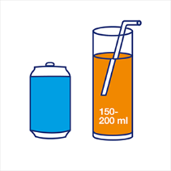
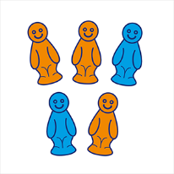
Treat the hypo immediately by eating or drinking 15 to 20g of a fast-acting carbohydrate. This could be:

- Three glucose or dextrose tablets.
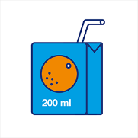
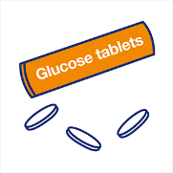
- Five jelly babies.
- A small glass of a sugary (non-diet) drink.
- A small carton of pure fruit juice.
- A glucose gel such as GlucoGel (as prescribed).

General Side Effects:
As with all prescribed medication, people react differently when taking insulin, and if there are noted complaints of headaches, nausea or flu-like symptoms within the first 72 hours of starting any new insulin, the GP/diabetic practitioner must be informed for advice and guidance.

Avoiding Injection Bruises and Lumps:
Bruising can happen when a tiny capillary is caught under the skin where the area has been injected.

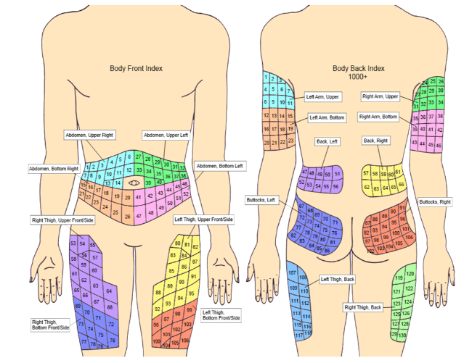
** It is important to rotate the injection areas and mark them on a body chart. **

Lipohypertrophy, also known as lipos, are hard lumps that can form if injections are in the same place too often. These lumps can be unsightly and can stop the insulin from working properly, so make sure injections are rotated.

Other side effects from frequent injections can be itching, rashes and other skin irritations. Changing injection sites may help with this.

Insulin and Weight Gain:
When people commence insulin, there may be a noted increase in weight and this can be due to matters such as how much insulin is taken, diet and type of insulin.

Insulin is a growth hormone, and any growth hormone taken will mean putting on more weight. Following diagnosis, it is likely that there has been a loss of weight in a short space of time, as this is one of the symptoms, and the weight gain is part of the recovery.

Insulin Overdose:
Insulin overdose can happen if more insulin is taken than needed. This can be very serious and may lead to severe hypos. The worst cases can make the person feel disorientated, cause them to have seizures and could even lead to death. If an insulin overdose is suspected then the GP/ medical professionals must be contacted immediately.

In the Case of a Severe Hypo:
If the person has a severe hypo and becomes unconscious, do not try to give food or drink as the person will not be able to swallow. Place the person into the recovery position and call an ambulance. Record all episodes of Hypo attacks in the individual’s daily documentation.

Testing Blood Sugar Levels:

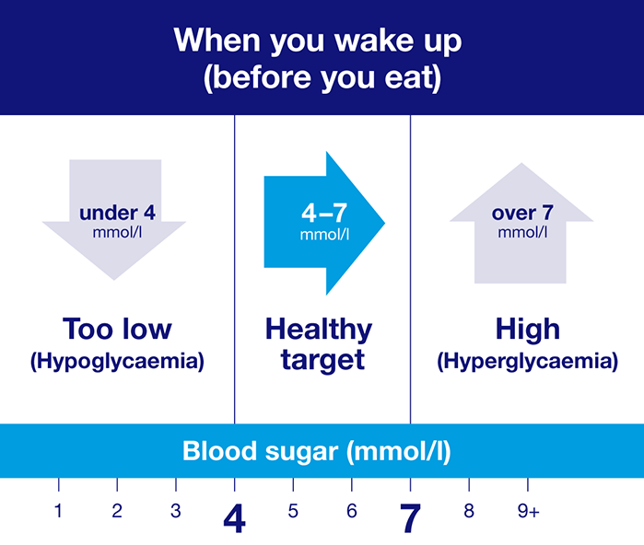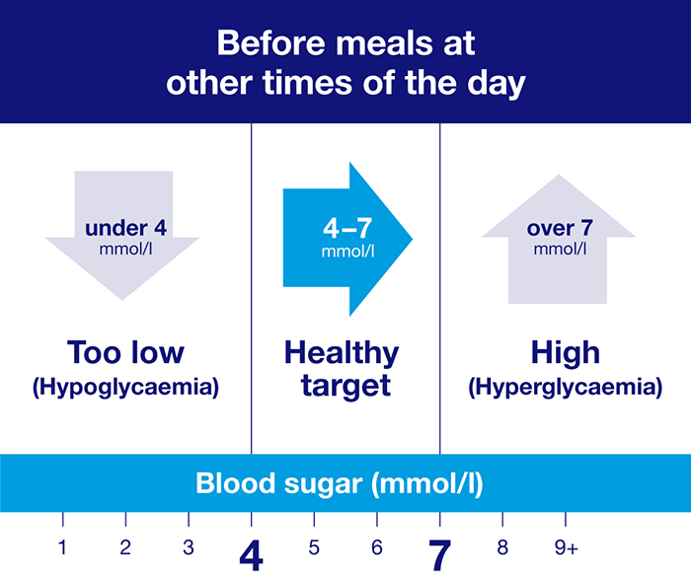
These are blood sugar level targets for adults with type 1 and type 2 diabetes. (Individual targets may differ; these are just examples).

Hyperglycaemic Episodes (Hyper)
If blood sugar levels are slightly above individual targets, there are usually no symptoms. But if the blood sugar levels become too high, the common symptoms include passing more urine than normal, being very thirsty, having headaches and feeling tired and lethargic. It is important that staff know how to treat a hyper to avoid developing ketones in the blood.

Hyperglycaemia, or a hyper, can happen when blood glucose (sugar) levels are too high – usually above 7mmol/l before a meal and above 8.5mmol/l two hours after a meal. This may be caused by having missed a dose of medication, have eaten more carbohydrate than either the body or medication (or both) can cope with, are stressed and are unwell from an infection, and have over-treated a hypo. It is important to have an idea of the normal range of BM levels for each individual to be able to detect problems of high of low sugar levels in the blood.

It is important that insulin and other diabetes medication is taken as prescribed, and all staff who are caring for a person with diabetes must have received training in diabetes.

Although feeling very thirsty is a symptom of a hyper, drinking a lot of water will not bring blood sugar levels down. It will only help to reduce the risk of dehydration and will not have an effect on blood sugar levels. Consistently high blood sugar levels noted need to be reported to the diabetic healthcare professionals or GP and advice and guidance followed.

Treating and Managing Hyperglycaemia (Hyper):
If the blood sugar level is slightly high for a short time, emergency treatment will not be necessary. But if it continues, fast action needs to be taken to avoid developing diabetic ketoacidosis (DKA).

If your blood sugar level is 15 mmol/l or more, check the urine for ketones. If ketones are present, it is likely that there is not have enough insulin in the body. In this instance contact the GP/diabetic professionals for guidance and advice. It may mean that the insulin dosage needs to be changed.

If there are regular high blood sugar levels, there needs to be a review of treatment to try to get back to the target range, as raised levels can increase the risk of developing diabetes complications.

Type 2 Diabetes
With type 2 diabetes, the body still breaks down carbohydrate from food and drink and turns it into glucose. The pancreas then responds to this by releasing insulin. But because this insulin cannot work properly, and the blood sugar levels keep rising, this means more insulin is released. For some people with type 2 diabetes, this can eventually tire the pancreas out, meaning their body makes less and less insulin. This can lead to even higher blood sugar levels and mean they are at risk of hyperglycaemia (see above).

Managing Type 2 Diabetes:
Type 2 diabetes can be managed through healthier eating, being more active or losing weight, but some people will need medication to bring their blood sugar down to their target level.
There is no cure for type 2 diabetes, but it is possible to put type 2 diabetes into remission, meaning blood sugar levels are healthy and there is no need to take diabetes medication.
There is no such thing as a special diet exclusively for people with type 2 diabetes; no two people with diabetes are the same. The latest advice is to make healthy choices more often and to have treats occasionally and in a small portion.

How to Check your Blood Sugar Levels:

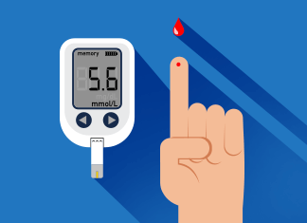
Finger-Pricking

This is how you find out what your blood sugar level is at that moment
in time. There should be individual blood testing meters, a finger prick
device, some test strips (test strips usually come in batches of 50 and
must work with the type of meter used), a lancet (a very short, fine
needle that can only be used once or they get blunt and are painful to use repeatedly), and a sharps bin (so needles can be disposed of safely). Machines need to be calibrated and checked to ensure that they are functioning properly.

Key Steps:

- Wash hands with soap and warm water.
- Do not use wet wipes as the glycerine in them can affect the test result.
- Make sure the person’s hands are warm so it is easier to get blood and won’t hurt as much.
- Take a test strip and slot it into the meter to turn it on. Some meters will have tests strips built in.
- Remove the cap from the finger prick device and put in a new lancet. Then put the cap back on and set the device by pulling or clicking the plunger.
- Choose which finger to prick but avoid the thumb or index finger.
- Place the device against the side of the finger and press the plunger.
- Use a different finger each time and a different area.
- Take the meter with the test strip and hold it against the drop of blood.
- The meter will tell you if the test strip is filled, usually by beeping.
- Before checking the reading, check the finger and use a tissue to stop any bleeding, then use it to take out the lancet and throw it away in the sharps bin.
- The meter will now show the result.
- Taking out the strip will usually turn the meter off.

Insulin Pens
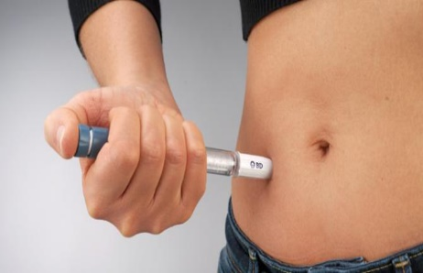
Insulin pens are common and are generally characterised by a
different shape and the fact that they use an insulin cartridge as
opposed to a vial. Some insulin pens use replaceable cartridges,
and others use non-replaceable cartridges and must be disposed
of after being used.

Some pens require gentle shaking before use. Once the cartridge is loaded, screw on a needle and prime the pen to clear air. Then dial in the exact dose that you require to deliver the insulin to the body.
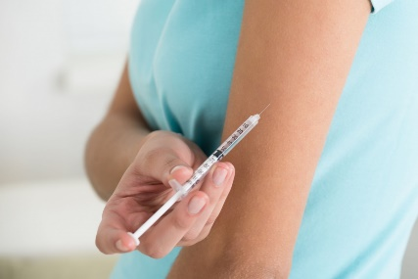
Insulin Injection

Before injecting, it is recommended to check the expiry date on the
insulin being used to ensure it is in date. Wash hands before handling
the syringe and starting the process.

- Preparing the Syringe for Injection:
Remove the caps at either end of the syringe, taking particular care with the cap covering the needle. Pull the plunger back to draw up air into the syringe. You should draw up the same number of units of air as the number of units of insulin you intend to inject.

- Preparing the Insulin Vial:
With the insulin vial standing upright, push the syringe needle into the vial and inject the air into the vial. This ensures the pressure inside the vial helps you to draw up insulin. If the insulin is a cloudy insulin, roll the vial gently between the palms of your hands until the insulin is fully mixed.

- Drawing Up the Insulin:
Hold the vial of insulin upside down and push the needle of the syringe into the vial. Ensure that the end of the needle of the syringe is surrounded by the insulin and not by air. Draw up the required number of units plus a few units more.

- Remove Any Bubbles:
Hold the syringe with the needle pointing up and tap the syringe with a finger or fingernail to move any bubbles, that might be in the syringe, towards the top of the syringe. With the syringe still upright, push the plunger into the syringe until the required number of units remain in the syringe. Remove the syringe from the vial. If air is still in the syringe, you will need to repeat from step 3.

- Prepare a Place to Inject:
Insulin should be injected into a soft, fatty area of the body. The belly, the top of the thighs and the buttocks can be used for injections. The top of the upper arm can be used if there is sufficient fat on the arms. Pick up a fold of skin with your fingers. If the skin feels stiff, pick a nearby area of softer skin.

- Injecting the Insulin:
Push the needle into the fold of skin at a right-angle to the skin. With the needle fully in your skin, deliver all the insulin by pushing down the plunger of the syringe. Once the insulin has been delivered, hold the needle in the skin for 10 seconds before removing the needle. This will help to prevent insulin leaking out.

- Disposing of the Needle:
Insulin syringes should only be used once. When the injection is complete, the syringe needs to be disposed of appropriately. A specialist needle clipping device can be used, which removes the needle from the syringe before disposal. The syringe, whether with the needle intact or not, should be disposed of in a medical sharps container.

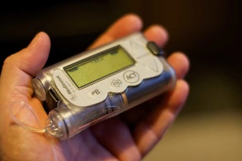
Insulin Pumps

Insulin pumps are portable devices attached to the body that
continuously deliver amounts of rapid or short acting insulin via a
catheter placed under the skin.

Most insulin pumps (tethered insulin pumps) work by sending insulin, stored in a reservoir within the pump, into the body via an infusion set – a thin plastic tube attached to either a steel needle or a plastic cannula (a very narrow plastic tube). The needle or cannula is inserted into the subcutaneous tissue (the layer of fat tissue just beneath the skin), enabling the insulin to be absorbed gradually into the bloodstream.

Another common type of insulin pump is a patch pump which largely works in the same way except that patch pumps attach directly to the skin and therefore do not require a line of plastic tubing to help deliver the insulin to the cannula.

HbA1c Test
As well as regularly testing blood sugars, at least once a year you will be asked to have an HbA1c test. This checks the average blood sugar levels and can help to spot trends over time.
This is an essential diabetes health check. Even slightly high HbA1c levels can lead to serious complications with eyes, feet, heart and kidneys.

Complications of Diabetes
High blood sugar levels can seriously damage parts of the body, including feet and the eyes.
Chronic complications are long-term problems that can develop gradually, and can lead to serious damage if they go unchecked and untreated such as:

Eye Problems (Retinopathy):
Diabetic retinopathy can develop which can affect eyesight. If retinopathy is picked up – usually from an eye screening test - it can be treated, and sight-loss prevented.

Foot Problems:
Diabetes can cause a risk of serious foot problems which can lead to amputation if untreated. Nerve damage can affect the feeling in the feet and raised blood sugar can damage the circulation, making it slower for sores and cuts to heal.

Heart Attack and Stroke:
High blood sugar levels for a period of time can damage blood vessels which can sometimes lead to heart attacks and strokes.

Kidney Problems (Nephropathy):
Diabetes can cause damage to the kidneys over a long period of time, making it harder to clear extra fluid and waste from the body. This is caused by high blood sugar levels and high blood pressure. This can be described as diabetic nephropathy or kidney disease.

Nerve Damage (Neuropathy):
Some people with diabetes may develop nerve damage caused over time by high blood sugar levels. This can make it harder for the nerves to carry messages between the brain and every part of the body so it can affect sight, hearing, sensory touch and movement.

Gum Disease and Other Mouth Problems:
Too much sugar in the blood can lead to more sugar in saliva. This brings bacteria that produces acid which attacks tooth enamel and damages gums. The blood vessels in the gums can also become damaged, making gums more likely to get infected.

** Ensure that you record BM readings accurately and legibly in the appropriate section of the care documentation. **
Diabetes Passport
The care service will ensure the residents have a diabetes passport in place for all diabetic service users:

https://www.diabetes.org.uk/resources-s3/2017-10/Residents%20passport_care%
20homes_2014.pdf
Photographs used in this policy may differ from those used in different organisations and should only be viewed as an example.

Service Specific Information
Where are blood sugar monitors stored?
Where are the diabetes passports kept? Or is the information included solely within the care plans?
How often are the blood sugar monitors calibrated? And who is responsible for this?
Who is responsible for re-ordering blood sugar test strips?
Is there a clear risk management plan in place?
Who would be responsible for checking blood sugars?
Who is responsible for the follow-up of abnormal blood sugar readings?
Who is responsible for updating the care plan and risk assessment, if required?
- Equality Impact Assessment

Equality Impact Assessment Checklist |  | Yes/No? | Comments
1. | Does the procedural document affect one group less or more favourably than another on the basis of:
 | - Race? | No
 | - Ethnic origins (including gypsies and travelers)? | No
 | - Nationality? | No
 | - Gender? | No
 | - Culture? | No
 | - Religion or belief? | No
 | - Sexual orientation, including lesbian, gay and bisexual people? | No
 | - Age? | No
2. | Is there any evidence that some groups are affected differently? | No
3. | If you have identified potential discrimination, are there any exceptions valid, legal and/or justifiable?
4. | Is the impact of the procedural document likely to be negative? | No
5. | If so, can the impact be avoided?
6. | What alternatives are there to achieving the procedural document without the impact?
7. | Can we reduce the impact by taking different action?

If you have identified a potential discriminatory impact of this procedural document or need advice, please document the action required to avoid/reduce this impact.

