Nasogastric Tube Feeding
This document is uncontrolled when downloaded or printed

Copyright © Care4Quality Ltd. All rights reserved.

Reference Number | REGCP07
Version | 1
Author | D Martin
Owned by:
Date ratified:
Ratified by:
(Signed)
Issue Date
Review Date
(Signed)
Target Audience | Registered Managers, Registered Nurses, Care Team

Contents
1 | Purpose and Application
2 | Responsibilities
3 | Legislation and Regulation
4 | Nasogastric Tube Feeding: Policy & Procedure
5 | Equality Impact Assessment

- Purpose and Application

This policy has been developed to provide guidance and information about nasogastric tube feeding, covering:

Risks of nasogastric tube feeding
How is the tube inserted?
How to prevent and treat tube blockage
Nasogastric monitoring
What happens after the tube has been inserted?

The policy will apply to:

- Permanent employees
- Temporary employees
- Agency workers

It will be the responsibility of the managers to take any necessary action if this policy is not adhered to, taking into account the relevant regulatory responsibility.

- Responsibilities

The nominated individual is accountable for the implementation of this policy in its entirety. They are a key contact for the service.

The registered manager and any trained nurses are responsible for the implementation of this policy and to evidence training in recognition and care for nasogastric tube feeding.

Any care staff that are aware of how to support a service user with nasogastric tube feeding.

- Legislation and Regulation

Health and Social Care Act 2008 (Regulated Activities) Regulations 2014: Regulation 12

The intention of this regulation is to prevent people from receiving unsafe care and treatment and prevent avoidable harm or risk of harm. Providers must assess the risks to people's health and safety during any care or treatment and make sure that staff have the qualifications, competence, skills and experience to keep people safe.

Providers must make sure that the premises and any equipment used is safe and where applicable, available in sufficient quantities.
Providers must prevent and control the spread of infection. Where the responsibility for care and treatment is shared, care planning must be timely to maintain people's health, safety and welfare.

CQC understands that there may be inherent risks in carrying out care and treatment, and they will not consider it to be unsafe if providers can demonstrate that they have taken all reasonable steps to ensure the health and safety of people using their services and to manage risks that may arise during care and treatment.

CQC can prosecute for a breach of this regulation or a breach of part of the regulation if a failure to meet the regulation results in avoidable harm to a person using the service or if a person using the service is exposed to significant risk of harm. They do not have to serve a Warning Notice before prosecution.

If administering medication covertly then an MCA and Best Interests Decision process will need to be followed. If a service user has capacity, you will need to gain their consent to administer their medication via the nasogastric tube. Authorisation for medication to be administered via this route needs to be agreed also with the supplying pharmacist and GP.

- Nasogastric Tube Feeding

Nasogastric (NG) feeding is where a narrow feeding tube is placed through the nose down into the stomach. The tube can be used to give fluids, medications and liquid food complete with nutrients directly into the stomach.

Nasogastric feeding can provide the fluids and nutrition the body needs while the person is unable to eat or drink adequate amounts. This may be because they have swallowing problems or have a poor appetite, amongst other reasons.

Risks of Nasogastric Tube Feeding
NG tube feeding is a safe procedure; however, it may carry certain risks as the tube could be misplaced when it is being inserted and may enter the lungs or the tube could be displaced once it is inserted. This means the tube would need to be removed and reinserted.

Displacement means when the tube moves out of the stomach due to coughing vigorously or vomiting, as an example. Displacement can happen anytime, but the risks are reduced by routinely checking that the tube is in the correct place by checking the pH (acidity) levels in the stomach. To reduce the risk of the tube being misplaced when it is inserted, the placement of the tube must always be checked before feeding starts.

How is the Tube Inserted?
The Nasogastric tube can be inserted either in hospital, in the care home or in the outpatient department. The insertion of the tube may cause brief and slight discomfort.

A narrow feeding tube will be passed through the nose down into the stomach by a qualified nurse who has been trained in this procedure. As the procedure will cause some discomfort, it is important that the person has a full explanation before commencing and consent is obtained. For people who may not have capacity to understand and agree to this procedure, the mental capacity act and best interest decisions needs to be carried out.

Once the NG tube is in place, the pH levels in the stomach must be tested, or it may be necessary to have a chest x-ray to confirm that it is in the correct position. The length of the external tube from the nostril-base is measured as this is used as a rough guide to check the tube position.

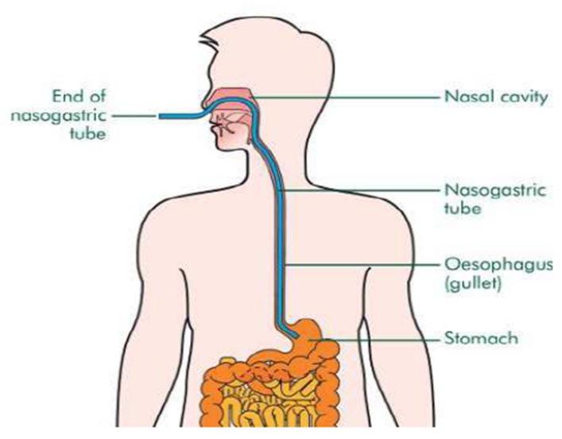

What Happens After the Tube Has Been Inserted?
After the tube has been inserted, feeding will be started through the tube. It will be connected to a feed ‘giving set’ and attached to a feed pump which will deliver the feed at the rate that has been prescribed. Before a feed, it is important to check the tube placement to make sure it has not moved. Normally, a 50ml syringe is used to draw up approximately 2-3mls of stomach fluid and this is placed on a pH paper strip. The paper strip should read pH 5.5 or below when compared to the chart. If the reading is higher than ph 5.5 the tube position needs to be checked and it may be advisable to seek advice and guidance from the enteral feed nurse or GP as it may be necessary to attend the local hospital for an appointment to check the position of the tube under x-ray.

Feed Regime
All feed regimes are prescribed on an individual basis and are a commercially prepared liquid feed that contains all the essential nutrients needed on a daily basis. Nasogastric feed regimes may be completed during the day or overnight and this is adjusted to suit the daily routine of the person.

Some people may receive part or all of their daily nutrients through the NG tube, depending on specific medical conditions and needs, and may also be given extra fluids through the tube over the day as required and advised. The dietitian will prescribe the volume and rate of feed to suit individual needs and will provide a feed regime to be followed.

People are still able to move around without too much restriction. If the feed is delivered through a pump, the feed and pump will hang on a stand and the pump will have a battery facility that will last for several hours; however, ideally, it should be plugged in at all times.

Personal care is important and to prevent infection. Hands must always be washed before and after handling the tube and feeding equipment. The nose and mouth need to be checked for redness, dry or cracked skin or soreness, and it may be necessary to lubricate the skin around the nose with a moisturizing cream to help prevent irritation and dry skin. Ensure any dressings that are used to secure the feed tube are clean and dry and changed if needed.

Mouth care is very important to maintain healthy teeth and gums. Plaque and tartar can build up very quickly and it is important to carry out appropriate dental care.

Nasogastric Monitoring
Whilst on a nasogastric feeding tube, it is important to monitor the progress carefully to make sure that the body is tolerating the food. The nasogastric tube will be checked before the start of feeding of all medications for correct placement and it is particularly important to check the placement of the tube if the person has been coughing vigorously, retching or vomiting, or if the tube appears to have changed in length.

The feeding regime will be monitored regularly, and weights need to be recorded on a regular basis. Any stomach or bowel problems, including nausea, vomiting, diarrhea or constipation, need to be discussed with the dietician and/or GP for advice and guidance. Any changes or discomfort need to be documented in the daily notes and a fluid chart needs to be in place to monitor the amount of fluid taken over a 24-hour period. Outside health professionals may also be included in the care and this can include a nutrition nurse, for example.

Medication, where possible, should be in liquid form. If not, please consult the doctor or pharmacist for advice. Always flush the tube before and after medication with 50mls of water as this will help prevent the tube from blocking. Flush the tube with 10mls of water between different medicines. It is advised to take each medicine separately rather than mixing them together. This also helps to stop the tube from blocking.

How to Prevent and Treat a Tube Blockage
The most effective way of preventing the tube from getting blocked is to flush regularly with at least 50mls (or quantity advise by the dietitian) of water. Always flush the tube before and after feed and medications. Do not put anything down the tube other than feed, water and medication as advised by the healthcare professionals (GP, dietician, pharmacist, nutrition nurse).

If the nasogastric tube becomes blocked even after attempted water flushes, do not force fluid through the tube. Contact the nutrition nurse or dietitian for advice and guidance as it may be necessary to replace the tube.

Feed Storage
Once opened, feed should be stored in a fridge and unused feed thrown away after 24 hours.

All pictures are for example only and may appear different from those used in the service.

- Equality Impact Assessment

Equality Impact Assessment Checklist |  | Yes/No? | Comments
1. | Does the procedural document affect one group less or more favourably than another on the basis of:
 | - Race? | No
 | - Ethnic origins (including gypsies and travelers)? | No
 | - Nationality? | No
 | - Gender? | No
 | - Culture? | No
 | - Religion or belief? | No
 | - Sexual orientation, including lesbian, gay and bisexual people? | No
 | - Age? | No
2. | Is there any evidence that some groups are affected differently? | No
3. | If you have identified potential discrimination, are there any exceptions valid, legal and/or justifiable?
4. | Is the impact of the procedural document likely to be negative? | No
5. | If so, can the impact be avoided?
6. | What alternatives are there to achieving the procedural document without the impact?
7. | Can we reduce the impact by taking different action?

If you have identified a potential discriminatory impact of this procedural document or need advice, please document the action required to avoid/reduce this impact.

