Colostomy and Stoma Care
This document is uncontrolled when downloaded or printed
Copyright © Care4Quality Ltd. All rights reserved.

Reference Number | REGCP04
Version | 1
Author | D. Martin
Owned by:
Date ratified:
Ratified by:
(Signed)
Issue date
Review date:
(Signed)
Target Audience | Registered Managers, Registered Nurses, Care Team

Contents
1 | Purpose and Application
2 | Responsibilities
3 | Legislation and Regulation
4 | Stoma and Colostomy Care
5 | Equality Impact Assessment

- Purpose and Application

This policy has been developed to provide guidance and information about colostomy and stoma care:

What is a Stoma/Colostomy?
Managing the Skin Around the Stoma and Applying the Stoma Product
Keeping Peristomal Skin Healthy
Potential Problems
Dietary Advice

The policy will apply to:

- Permanent employees
- Temporary employees
- Agency workers

It will be the responsibility of the managers to take any necessary action if this policy is not adhered to, taking into account the relevant regulatory responsibility.

- Responsibilities

The nominated individual is accountable for the implementation of this policy in its entirety. They are a key contact for the service.

The registered manager and any trained nurses are responsible for the implementation of this policy.

Any care staff that have been deemed competent by the care organisation in helping to support a service user with stoma or colostomy care.

- Legislation and Regulation

Health and Social Care Act 2008 (Regulated Activities) Regulations 2014: Regulation 12

The intention of this regulation is to prevent people from receiving unsafe care and treatment and prevent avoidable harm or risk of harm. Providers must assess the risks to people's health and safety during any care or treatment and make sure that staff have the qualifications, competence, skills, and experience to keep people safe.

Providers must make sure that the premises and any equipment (including medical devices) used is safe and where applicable, available in sufficient quantities.

Providers must prevent and control the spread of infection. Where the responsibility for care and treatment is shared, care planning must be timely to maintain people's health, safety, and welfare.

CQC understands that there may be inherent risks in carrying out care and treatment, they will not consider it to be unsafe if providers can demonstrate that they have taken all reasonable steps to ensure the health and safety of people using their services and to manage risks that may arise during care and treatment.

CQC can prosecute for a breach of this regulation or a breach of part of the regulation if a failure to meet the regulation results in avoidable harm to a person using the service or if a person using the service is exposed to significant risk of harm. CQC do not have to serve a Warning Notice before prosecution.

- Colostomy and Stoma Care: Policy & Procedure

What is a Stoma/Colostomy?
A stoma is the result of an operation to remove disease such as cancer, Crohn's disease, or diverticulitis, or from a bowel obstruction or injury to the digestive or urinary system. It is an artificial opening that allows faeces or urine either from the intestine or from the urinary tract to pass. There are three main types of stoma related to the digestive and urinary system - these are: colostomy, ileostomy and urostomy.
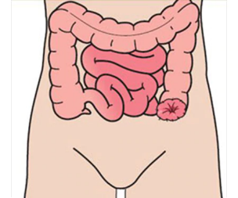
Colostomy
In a colostomy operation, part of the colon is brought to the surface of the abdomen to form the stoma. A colostomy is usually created on the left-hand side of the service user’s abdomen. Stools in this part of the intestine are solid and because a stoma has no muscle to control defecation, will need to be collected using a stoma pouch.

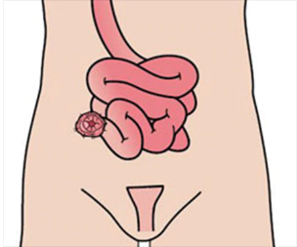
Ileostomy
In an ileostomy operation, a part of the small bowel called the ileum is brought to the surface of the abdomen to form the stoma. An ileostomy is typically made in cases where the end part of the small bowel is diseased.

Urostomy
During the most commonly performed urostomy surgery, called an ileal conduit, a six- to eight-inch piece of the small bowel (the ileum) is made into a conduit (or pipeline) for urine. The remainder of the small bowel is reconnected so the bowel will function as it did before surgery. The ureters are removed from the bladder and joined to the piece of ileum (small bowel). An isolated part of the intestine is brought onto the surface

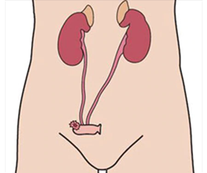

of the right-hand side of the abdomen and the other end is sewn up. The ureters are detached from the bladder and reattached to the isolated section of the intestine. This section of the intestine is too small to function as a reservoir, and there is no muscle or valve to control urination, so a urostomy pouch is used to collect the urine.

Managing the Skin Around the Stoma and Applying the Stoma Product
Keeping the skin around the stoma in good condition is most important to make life with a stoma pouch secure, comfortable, and worry-free. It is important to keep the skin around the stoma healthy. Contact between stoma output and skin causes skin irritation that then affects how well the adhesive on the appliance sticks to the body. This can create a vicious circle of more leakage and even more irritated skin. In order to keep the skin healthy, it is important that:

- The skin is clean and completely dry before applying the adhesive.
- The hole in the adhesive is adjusted so that it exactly fits around the stoma.
- The backing from the stoma product is removed to reveal the adhesive contact (check individual product instructions and guidance for use).
- The stoma product is placed onto the stoma area and make sure that there is full contact between the adhesive and the skin.
- The appliance is changed as soon as any discomfort or itching is felt.
- The size of the stoma is checked regularly.
- You make sure that the stoma appliance and accessories are appropriate. Seek advice and guidance from the stoma care nurses if you are unsure of the appropriate product size or shape.

** Prior to application of the stoma product, ensure that relevant PPE and infection control measures have been taken. Prepare everything you will need to complete the procedure. Ensure that all waste is disposed of safely and in accordance with the organisational clinical waste protocols. **

It is important that there is always a supply of stoma products available for use and that all assistance if offered to allow the service user to be as independent as possible within the confines of the appropriate risk assessment. A care plan and risk assessment need to be created on an individual basis in consultation with the service user to make sure all aspects of care are covered and agreed.

Keeping Peristomal Skin Healthy
Having a well-fitting product solution plays an important role in preventing leakage and keeping skin healthy. To secure optimal adhesion, the baseplate should be applied to clean and completely dry skin. Clean water is sufficient for the cleaning of the stoma and skin around it.

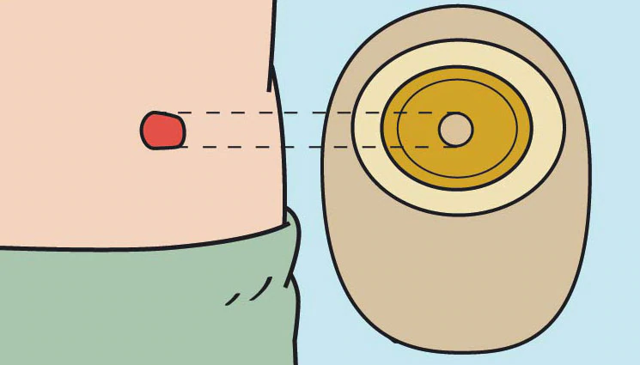
When it comes to fitting the ostomy baseplate, the hole should be cut so that it fits the diameter and shape of the stoma exactly.

Potential Problems

Symptoms of Ostomy Leakage
Look for any stoma output, either on the skin or on the back of the adhesive plate. Even if there is no direct visual sign of leakage, be aware of anything unusual, such as if the adhesive plate looks 'melted' (because the adhesive has reacted with the output).

If the skin is red, sore, and moist, maybe even bleeding a little, but there has been no leakage, the issue could be 'mechanical'. That means the skin is simply being irritated from removing the pouch too often, too vigorously, or from cleaning or scrubbing the skin too roughly. To avoid this, try to be as gentle as possible, both when removing the adhesive baseplate and when cleaning the skin. Try to peel the plate off slowly rather than ripping or tearing it off. Using the other hand to hold the skin tight can help reduce stress on the skin. Adhesive removers may also help when removing the appliance. Leakage can also be a result of poor adherence or erosion of the adhesive and can typically be due to cutting the hole in the baseplate inaccurately. If the hole is too big, the skin exposed to faeces or urine will eventually become irritated.

Food Blockage
A food blockage can cause cramping pain and watery stool, and the abdomen and ostomy may become swollen. If it is thought that there is a food blockage, inform the GP/district nurse for advice and guidance. It is also important to drink plenty of water and follow advice from the GP.

Ballooning and Pancaking
Ballooning happens when there is a build-up of gas in the stoma pouch, making it inflate like a balloon. Most pouches have charcoal filters that help deal with wind by deodorizing and releasing it from the pouch. But if the filter capacity cannot handle the gas produced, or if it has become moist or blocked by solid output from the stoma, gas build-up can occur. If ballooning does occur, gas can be released from the pouch by gently opening the bag to release the gas or by changing the bag altogether. One of the main ways to prevent ballooning is to minimise the amount of gas the digestive system produces. Chewing food thoroughly really helps, as can limiting food and drinks that are known to produce a lot of gas. These could be nuts, beans, carbonated drinks, or sparkling wine.

Pancaking happens when there is a vacuum in the stoma bag and the bag sticks together. This stops the output from dropping to the bottom of the bag and can block the filter. There is then a risk that the pouch will be pushed off the abdomen. Blowing air into the pouch before putting it on will help stop a vacuum from occurring. In addition, a drop of oil or lubricant in the pouch will help the output to get to the bottom of the bag.
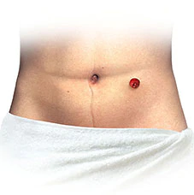
Healthy skin around the stoma looks the same as the skin on the rest of the stomach.

Dietary Advice
In general, people with an ostomy can eat and drink what they want unless they have been given counter-advice from other health professionals. Often, there is a reduction in appetite the first 4-6 weeks after an ostomy procedure and it may be necessary to supplement the diet with protein and energy drinks (seek GP/stoma nurse guidance if concerned). There is no reason to restrict certain foods. Some foods, especially high-fibre foods, can cause a food blockage, where undigested parts of food block the bowel, so it is important to encourage chewing all food well. The skins of some fruits and vegetables can be tough, so it can be of value to peel them to avoid any problems, especially potato skins and apple skins. Ensure catering staff are aware and seek advice from the stoma nurse or dietician if problems are noted.

Fluid intake affects the digestive system. It is recommended that at least 2 litres of liquid should be consumed a day; this also helps to avoid constipation. Beverages recommended can include coffee and tea, but carbonated drinks in general can cause gas. Be aware that alcohol can cause dehydration, so it is important to make sure to offer and have available a fresh supply of water at all times. If constipation is a problem, this must be discussed with the GP and then medication offered as appropriate and prescribed.

People with an ileostomy can lose two to three times more liquid and salt than other people through the stool, so sprinkling a little salt on food may be a good idea, but this may need to be monitored and advice taken from other health professionals.

It is important that there are staff on duty trained in the care of stomas and that their competency is checked to ensure they are up to date with care practices.

5. Equality Impact Assessment

Equality Impact Assessment Checklist |  | Yes/No? | Comments
1. | Does the procedural document affect one group less or more favourably than another on the basis of:
 | - Race? | No
 | - Ethnic origins (including gypsies and travelers)? | No
 | - Nationality? | No
 | - Gender? | No
 | - Culture? | Potentially | There is a possibility that changes in diet due to cultural and religious choices may affect the pattern of care and support required around stoma and colostomy care. Staff need to be aware of any cultural preferences and choices of the service user.
 | - Religion or belief? | Potentially
 | - Sexual orientation, including lesbian, gay and bisexual people? | No
 | - Age? | No
2. | Is there any evidence that some groups are affected differently? | No
3. | If you have identified potential discrimination, are there any exceptions valid, legal and/or justifiable?
4. | Is the impact of the procedural document likely to be negative? | No
5. | If so, can the impact be avoided?
6. | What alternatives are there to achieving the procedural document without the impact?
7. | Can we reduce the impact by taking different action?

If you have identified a potential discriminatory impact of this procedural document or need advice, please document the action required to avoid/reduce this impact.

