Name:
Covid-19 and Consent
Easy Read Information Leaflet & Consent Form
Date:
Name of Staff Member Supporting:

A member of staff or a carer can support you to read this booklet. They will be able to answer any questions that you have.
What is consent?
You should always be involved in making decisions about your life.
You should always be involved in making plans for your future.
When you say that you agree to something happening, you are giving your consent.
When you give your consent, it is only for what you have been asked about at that time.
Before you give your consent you will be told everything you need to know. You must be given enough information to help you decide.

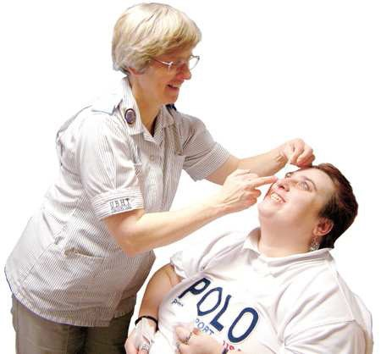
You may be asked to consent to test for Coronavirus
A member of staff will ask you if you want to have a test for Coronavirus, and if you do, they will help you
Before you make up your mind, you need to be given information about:
- What they will need to do
- Why it needs to be done
- What will happen next
- How it can help keep you safe

How will people know I am giving consent?
You can say yes
You can make a sign
You might be asked to sign something to say you agree
You can say yes. You can say no. It is up to you

Do you need help to make up your mind?

You might want to ask questions like:
- How long will it be before I get the result
- Will I need to go into hospital?

What will happen if I say no?

Talk it over with a friend, relative or carer. They might also want to ask questions.

You can always change your mind about giving consent.

Take time to think about
What will the staff member do?

Every month the staff may test you for Corona Virus. You can choose not to have this done.

The staff will use a swab to take a sample from your mouth and nose

The staff will send the swabs to be tested

You will have to wait for your test results

The staff will explain your test results as soon as we get them

If you are unsure of the process at any time, you can say No!

Do you consent to having a Covid 19 Swab Test?

Yes or No

Date:

Signed:

Signed (Staff member supporting):

Role of Staff Member:

Further Information can be obtained at:

W: www.care4quality.co.uk
T: 01579 324787
E: admin@care4quality.co.uk

