Easy Read Whistleblowing Policy
 | "Whistleblowing" is when you tell people about something serious that should not be happening.
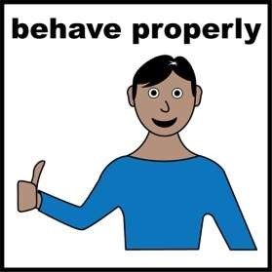 | SERVICE aims to be honest and responsible. We expect our staff to behave properly.
 | If you find out someone is doing something wrong, you must tell XXXX
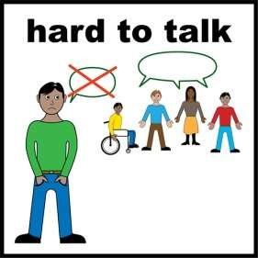 | Please don't find it hard to talk about it.  You will not get in trouble for sharing the information.
Staff want to solve any problems.

Tell us your concerns and let us try to solve any problems before you tell anyone else.
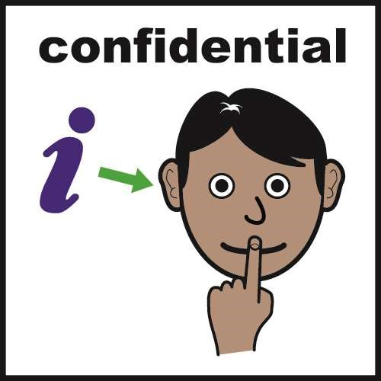 | SERVICE will not tell people that you have spoken to us about the issue, unless we really have to.
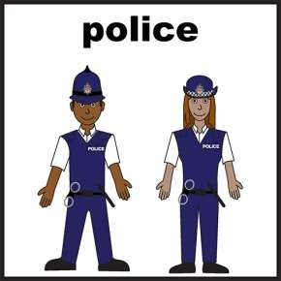 | If a crime has been committed we will have to tell the police.
 | Please give truthful information.
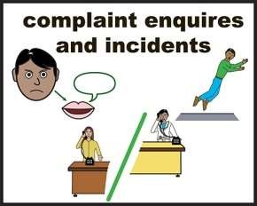 | Someone will be chosen to look into your complaint.
 | When we have investigated your complaint we will write to you to tell you what we have found.
 | If you have anything you would like to talk about please contact XXXX on 000000000 or email xxxxx
If you feel you cannot speak to XX, you can speak to the following people:

XXXX on XXXX

