Hand Hygiene Competency Validation
Soap & Water
Alcohol Based Hand Rub (ABHR) (60% - 95% alcohol content)
Type of Competency: | - Induction  - Annual  - Other – Spot check
Employee Name: Job Role: _

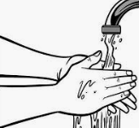  Hand Hygiene with Soap & Water | Competent
 | YES | NO
1. Checks that sink areas are supplied with soap and paper towels
2. Turns on taps and regulates water temperature
3. Wets hands and applies enough soap to cover all surfaces of hands
4. Vigorously rubs hands for at least 15 seconds including palms, back of
hands, between fingers, and wrists
5. Rinses thoroughly keeping fingertips pointed down
6. Dries hands and wrists thoroughly with paper towels
7. Discards paper towel appropriately
8. Uses paper towel to turn off tap to prevent contamination to clean hands
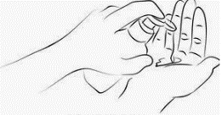
Hand Hygiene with Alcohol Based Hand Rub

9. Applies enough product to adequately cover all surfaces of hands
10. Rubs hands including palms, back of hands, between fingers until all
surfaces dry
General Observations
11. No artificial nails or enhancements
12. Natural nails are clean, well groomed, and tips less than ¼ inch long
13. Skin is intact without open wounds or rashes
Comments or follow up actions:

/

Employee Signature Assessor Signature Date

