Topical Administration Guidance

Administering topical medication – Key Points:
- Check expiry date before use
- Highlight any short expiry dates as a reminder to all staff
- Record the date opened and the calculated expiry on the medicine package/label. Some packaging does not allow for the pharmacy label to be placed on the product e.g. eye drops. In these circumstances the outer packaging will have to be endorsed with the date of opening. It is essential that the product remains in the outer packaging throughout duration of this treatment.
- Any product whose appearance suggests it may be unfit for use should be discarded.
- Use a Topical Medicines Application Record (TMAR) for recording administration of topical preparations and expiry date information for topical medications. A suggested topical medicines application record sheet is enclosed.

Procedure for service users unable to apply their own prescribed topical medication:
- A Registered Nurse or Senior Care Assistant should complete a Topical Medicines Application Record (TMAR) for each topical medication prescribed. As it is a handwritten document it should be countersigned. Ideally this should include a body map.
- The TMAR should be kept in the resident’s room.
- The Care Assistant, Registered Nurse or Senior Care Assistant should sign the TMAR when they have applied a topical medicines in line with the prescription instructions
- The Medical Administration Record (MAR) chart should state “see TMAR chart”
- At the end of each 28 day cycle the TMAR should be attached to the corresponding MAR chart to provide a full record of administration
- Gloves should always be used when applying topical medication

Table of Suggested Expiry of Topical preparations from Date of Opening
NB Due to the lack of available evidence on generic expiry dates of creams/ointments the following expiry dates are suggested

Formulation and packing | Suggested expiry after opening unless otherwise stated by manufacturer and still within manufacturer’s  expiry date | Rationale
Tubs of creams/ointments | 1 month | The contents are exposed and can become contaminated
Tubs of creams/ointment decanted from bulk container | 1 month or seek community pharmacy or dispensary advice | As above and decanting from bulk container into another container could introduce contamination
Tubs of cream specially made for individual | Seek community pharmacy or dispensary advice | Dependant on stability of product
Tubes of creams/ointments | 3 months | Closed container, contents less exposed to environment
Pump dispenser packs of creams/ointment | Manufacturer’s expiry | Closed container, contents not openly exposed to environment

Some products now show an expiry symbol. However, in the care home setting where storage conditions may be variable it is recommended that the above suggested expiry dates are followed.
Any products whose appearance suggests it may be unfit for use should be discarded – irrespective of expiry date. If there is any doubt contact the community pharmacy/dispensary for advice.

As a guide the following table shows the difference in suitable quantities of topical creams/ointments as opposed to topical corticosteroids for an adult:

AREA OF BODY | CREAMS/OINTMENTS  Twice daily application |  | CORTICOSTEROIDS  Single daily application
 | Per Week | Per Month | Per Week | Per Month
Face | 15-30g | 60-120g | 8-15g | 30-60g
Both hands | 25-50g | 100-200g | 8-15g | 30-60g
Scalp | 50-100g | 200-400g | 8-15g | 30-60g
Both arms | 100-200g | 400-800g | 15-30g | 60-120g
Both legs |  |  | 50g | 200g
Trunk | 400g | 1600g | 50g | 200g
Groins and genitalia | 15-25g | 60-100g | 8-15g | 30-60g
Special advice for administering topical corticosteroids:
These should be applied no more frequently than twice daily and should be spread thinly. The length of cream or ointment expelled from a tube can be measured in “fingertip units” (the distance from the fingertip to the first crease of the finger in an adult index finger), One “fingertip unit” (approximately 500mg of cream or ointment) is enough to cover an area that is twice that of the flat adult handprint (palm and fingers). ¹
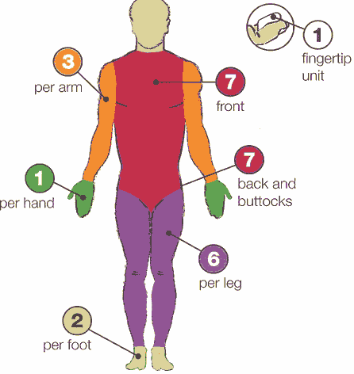
¹BNF 66 – September 2013
Resources:
Continuing Professional Pharmacy Education (CPPE) Supporting Care Homes in Medicines Management April 2007 Expiry dates Sheffield care homes steering group 2010

Topical Medicines Application Record Sheet

Name of Resident: |  |  |  |  |  | D.O.B: | Room No: |  | GP: |  | Allergies:
Name of Topical Preparation: |  |  |  |  |  |  |  |  | Completed by: |  | Checked by:
Site of application (mark on body map):
How to be applied e.g. thinly, liberally, use as a soap:
Frequency of application e.g. daily, after washing:
Month: |  | Start date: |  |  | End date: |  |  | Start day: |  | 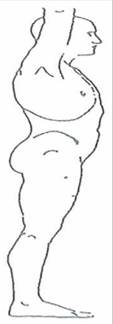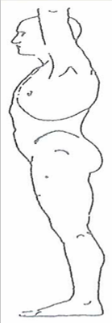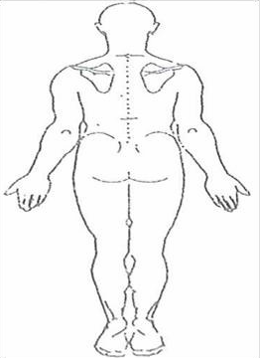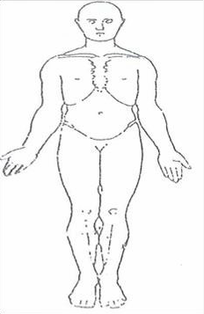
Date | Time |  | Signature | Time |  | Signature | Time |  | Signature
Storage e.g. fridge |  |  |  |  |  | Date opened: |  |  |  | Expiry date after opening:

