Service Quality Audit Tool 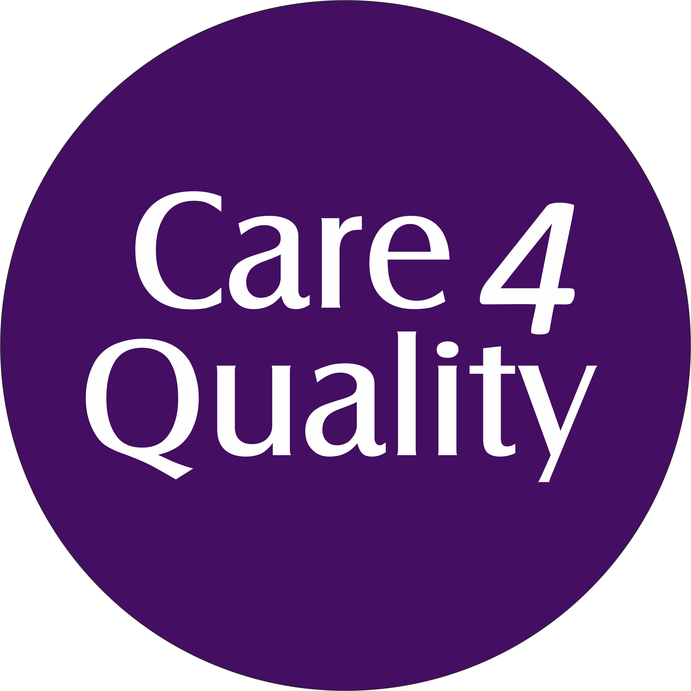

Learning Disability Services

Provider

Service

This Service Quality Audit Tool is designed to support you in considering compliance issues within the environment of your service in relation to Learning Disability specific practices.

The Audit should be completed every 6 months as a standard and within a week of the request of the Provider Information Return (PIR) by the regulator.

The audit should be completed in chronological order with an Action Plan in place for each core area.The Audit Tool focuses on 5 Domains. The domains are appropriate for the following service types:
- Nursing Homes
- Residential Care Services
- Supported Living Services
- Extra Care Housing Services
- Domiciliary Care Services

The ‘Overall Scoring’ at the end of each Core Domain should be calculated against the amount of ‘Yes’ ticks which have been achieved. The ‘Potential Total’ should be completed for questions that you feel are appropriate for your service – i.e. the Potential Total is equal to the number of indicators that you have answered ‘Yes’ or ‘No’ to. You will then need to calculate a percentage score for each Domain by using the following formula: Percentage (Overall scoring divided by Potential Total x 100) = %

The individual Domain scores can then be entered onto the table at the bottom of the Audit Tool, this will indicate where an Action Plan is needed and what areas to focus on. An Action Plan should be completed for each ‘No’ answer. The Action Plan Tool should be used and it should be stated clearly on this who the responsible person is and when the task will be completed.

Service Specific Rating Judgement
Core Area: |  | Rating:
1 | Workforce Learning & Development
2 | Health and Social Care Needs
3 | Clinical Interventions & Documentation
4 | Capacity, Consent & Community Empowerment
5 | Social Equality & Integration
Overall Rating:

- Judgement Framework

Percentage Score: | Rating Outcome:
75 – 100% | Outstanding
50 – 75% | Good
25 – 50% | Requires Improvement
0 – 25% | Inadequate

Legislation Framework

The judgements are made against the particulars outlined within the following pieces
of legislation:

- Mental Health Act (1983)
- Human Rights Act (1998)
- Valuing People: Health Action Planning (2002)
- Valuing People Now (2003)
- Mental Capacity Act (2005)
- Deprivation of Liberty Safeguards (2006)
- UNCRPD (United Nations Convention on the Rights of People with Disabilities) (2007)
- Healthcare for All: Access to Healthcare for People with Learning Disabilities (2008)
- Health Act (2009)
- BILD Code of Practice (2010)
- Personalisation Through Person Centred Planning (2010)
- Equality Act (2010)
- Death by Indifference Campaign (2012)
- Care Act (2014)
- Health and Social Care Act (2008) (Regulated Activities) Regulations (2014)
- Positive and Proactive Care: Reducing the Need for Restrictive Interventions (2014)
- Communication Bill of Rights (2016)
- Skills for Care Guidelines (Person centred Care and Support Planning) (2016)
- Accessible Information Standard (2016)
- SCIE Guidelines (2017)
- CQC Guidance: Oral Health in Care Homes (2018)

- Core Area 1: Workforce Learning & Development

Audit Question: | Yes / No:
- Is there an ongoing training framework in place which supports the skill development of the workforce in relation to Learning Disability specific practices?
- Does the provider / service have access to specialist trainers who are qualified and well versed in the field of Learning Disability training?
- Are staff knowledgeable in relation to Learning Disability specific practices, such as SPELL, TEACCH, Intensive Interaction or PECS?
- Is the content and outcomes of the training delivered to staff practised within the service, i.e. can staff answer basic questions about each course topic?
- Are staff trained in using and responding to the unique communication needs and forms used by the people living in the service?
- Are new staff on induction provided with appropriate time to shadow experienced staff via a ‘mentor’ or ‘buddy’ system to gain a basic understanding of their role in supporting people?
- Do staff involve the people living in the service using their specific communication needs while responding and acting with kindness, compassion and respect?
- Are staff supported with additional Learning and Development opportunities beyond formal training, such as ongoing CPD and reflective practice sessions?
- Is the delivery of formal technical training delivered in a manner that meets the overall learning needs and styles of the workforce, and varied by trainer delivering these?
- Are staff teams adequately and consistently supported to keep up to date with current practice and research in the field of Learning Disability?

Overall Score:
Potential Total:
Percentage (Overall Scoring Divided by Potential Total X 100):

- Core Area 2: Health and Social Care Needs

Audit Question: | Yes / No:
- Do all people using the service have a Health Action Plan or Health Passport in place which meets the requirements of the Department of Health and Social Care Guidance (2002)?
- Where people using the service are prescribed anti-psychotic or anti-depressant medications, do they have regular access to a GP for a review of these as well as 6 monthly ECG’s?
- Does the service / provider subscribe to national campaigns which empowers people with a Learning Disability to take control of their health needs, such as the STOMP campaign?
- Are people with a Learning Disability supported and empowered to take control of their health needs, such as instigating health appointments with health professionals?
- Where possible, are people empowered to have End of Life Plans in place which do not have DNAR’s in place based solely on the clinical diagnosis of Learning Disability?
- Has each person using the service had a review undertaken with their allocated Social Worker in compliance with the requirement to do so under the Care Act (2014)?
- How are people supported to understand information regarding their medication and health needs and in a format that they can understand it in?
- Are people provided with suitable and sufficient access to the equipment they require that enables them to mobilise around their home while maintaining their safety, dignity and independence?
- Is there a clear record on file for each person using the service that evidences the access they have had with health and medical professionals relevant to their needs?
- Is there clear evidence in peoples Support Plans and Health Action Plans that staff supporting people have a good understanding of their health needs?

Overall Score:

Potential Total:

Percentage (Overall Scoring Divided by Potential Total X 100):

- Core Area 3: Clinical Interventions & Documentation

Audit Question: | Yes / No:
- Do Pre-Admission Assessments adequately detail people’s needs, and is this information used to form the basis of a Support Plan and Risk Assessments that addresses that need?
- Where people require specific interventions and support is this need identified with the Local Authority and managed so that the person is not placed at risk?
- Where there are ongoing clinical interventions is there evidence that the clinical outcomes are met by the staff team supporting the person?
- Are clinical recommendations by professionals delivered by a staff team that have the skills, knowledge and abilities to appropriately and competently act on these recommendations?
- Are clinical notes and formal clinical guidance from professionals to meet people’s needs kept up to date and reviewed regularly as required?
- Are there clear Support Plans and Risk Assessments in place that meets the overall needs and outcomes for people which are led and owned by the person?
- Are people empowered and supported to be placed at the centre of their support and they are encouraged to build and develop their circles of support?
- Do all staff have a good and working understanding of person-centred practices which enable people to make their own choices and decisions?
- Is the culture of the service one that is supportive, and outcome focused so that people using the service are empowered to take charge of their care and support?
- Is information provided in a format that meets the needs of the people using the service, and one that meets the Accessible Information Standard (2016)?

Overall Score:

Potential Total:

Percentage (Overall Scoring Divided by Potential Total X 100):

- Core Area 4: Capacity, Consent & Community Inclusion

Audit Question: | Yes / No:
- Do people with a Learning Disability have their capacity to consent assessed by Assessors who understand the process and framework of the Mental Capacity Act (2005)?
- Are people with a Learning Disability supported to make choices and decisions through having access to augmented or specific communication formats?
- Are there tools in place which support staff teams to assess people’s needs to ascertain and analyse behaviour patterns, such as the Dis-DAT Tool?
- Where people with a Learning Disability present with behaviours that challenge, is there evidence that the least restrictive and safe practices are used to prevent them coming to harm?
- Are people’s behavioural needs assessed so that their restriction to everyday community facilities is reduced and managed where possible?
- Are people using the service consistently provided to community-based activities and events of their own choosing on days and at times when they wish?
- Are people supported to have access to services as required, such as an IMCA (Independent Mental Capacity Advocate) or an Advocate?
- Are people with a Learning Disability supported to make friendships and relationships with people outside of those of the people they live with?
- Are the views of people with a Learning Disability honestly and consistently acted upon by staff supporting them in the way they want to be supported?
- Where people with a Learning Disability have been deemed to lack capacity do staff support them to continue to learn skills, be a part of a process and, where possible, to gain / regain capacity?

Overall Score:
Potential Total:
Percentage (Overall Scoring Divided by Potential Total X 100):

- Core Area 5: Social Equality & Empowerment

Audit Question: | Yes / No:
- Do people with a Learning Disability who have capacity supported to exercise their right to vote in local and national elections with sufficient supporting information?
- Are people with a Learning Disability supported to maintain their knowledge and interest in their local communities, as well as being supported to understand current affairs on a national level?
- Are people with a Learning Disability supported to understand and exercise their legal and civil rights as defined under the Human Rights Act (1998)?
- Are people with a Learning Disability supported to access information, advice and support as needed, such as the benefits system or the Citizens Advice Bureau?
- Are people with a Learning Disability empowered and supported to directly choose the staff they wish to provide support to them through a recruitment and selection process?
- Do people with a Learning Disability using the service understand their rights to complain in order to affect change, and is this information available to them in a format they can understand?
- When people with a Learning Disability complain or provide comments for feedback relating to the service, is this acted upon and evidenced?
- Does the service actively seek feedback from people with a Learning Disability, as well as members of their circles of support, and is this feedback honestly acted on?
- Where the service makes decisions in relation to their operating practices and / or workforce, is this done through consultation with the people using the service so that they maintain control?
- Where conflict may occur between different people using the same service, are the views of all parties involved listened to and acted on in the manner that they wish?

Overall Score:
Potential Total:
Percentage (Overall Scoring Divided by Potential Total X 100):

- Total Scores as a Percentage

Core Area | Percentage
1
2
3
4
5
Total Overall %

- Action Plan

Core Area: | Actions Required & Plan: | Target Date: | Responsible Person: | Date Completed:

- Audit Completed by:

Signature
Name
Role
Date

