Insulin Injection Sites
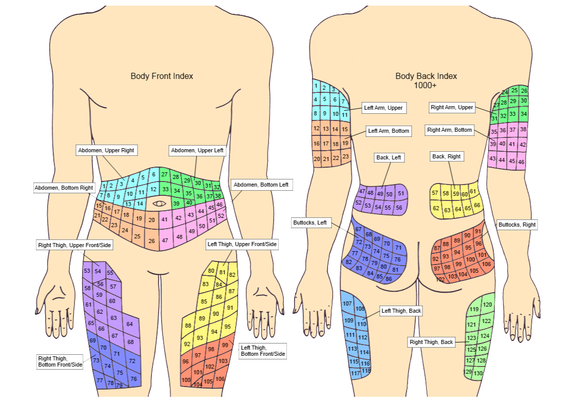
Self-administered insulin is injected or infused into the fatty tissue just under the skin. The body areas used most commonly for insulin injections are the abdomen, buttocks, and thighs. The backs of the upper arms may be used as well. To avoid skin problems, inject at least a fingers width away from your last injection. To avoid absorption problems, don’t inject near moles, scars or your navel.

Date | Site No | Time | Signature | Date | Site No | Time | Signature

